WEC WRITING PLAN NARRATIVE
School of Urban and Regional Planning
Florida Atlantic University
May 30, 2018

1. Writing Plan Cover Page for WEC Departmental Participation
School of Urban and Regional Planning
WEC Unit Name
Urban and Regional Planning |  | CDSI
Department |  | College
Jesse Saginor |  | Associate Professor
WEC Faculty Liaison (print name) |  | Title
jsaginor@fau.edu |  | 561-297-4283
Email |  | Phone

Date: 4/25/18 If Vote: /  # yes # total | ☐ Third Edition of Writing Plan

Date: May 30, 2018

☐ Second Edition of Writing Plan
☒ First Edition of Writing Plan
Writing Plan ratified by Faculty
The Writing Plan was created based on consensus and transparency throughout the process, which is an important aspect of public participation in the urban and regional planning discipline. This process relied on multiple meetings and additional feedback via email and surveys that were solicited from faculty, staff, students, and affiliates before and after meetings. A majority of the Writing Plan is driven largely based on faculty input to drive the plan over the next two years as we gauge student impacts and writing improvements. Faculty input includes full-time faculty, instructors, and part-time adjuncts. The courses for assessment over the first two years were voluntarily chosen by the faculty who teach those courses to participate in the pilot program. Various processes to maximize feedback are also discussed in the Writing Plan.
Process by which Writing Plan was ratified within unit (vote, consensus, other- please explain):

2. Unit Profile:

-----------------------------------------------------------------------------------------------------------------------------------------------------
WEC Process |  | Date |  | # participated | / | # invited
Intro Meeting for Faculty |  | 10/20/17 |  | 18 | / | 24
Online Faculty Survey |  | November-December, 2017 |  | 8 | / | 18
Online Student Survey |  | November-December, 2017 |  | 54 | / | 162
Online TA/GI Survey |  | These students were in the online student pool. |  | 0 | / | 0
Meeting 1 |  | 12/6/17 |  | 12 | / | 15
Meeting 2 |  | 2/28/18 |  | 11 | / | 15
Meeting 3 |  | 4/4/18 |  | 12 | / | 15
Meeting 4 |  | 4/25/18 |  | 12 | / | 15

Major(s)  Please list each major your Unit offers: |  | Total # students enrolled in major as of Spring 2018 |  | Total # students graduating with major AY 17-18*
Bachelor of Urban Design |  | 53 |  | 22
Bachelor of Urban and Regional Planning |  | 84 |  | 25
Master of Urban and Regional Planning |  | 25 |  | 10
Total:

Number of Tenured and Tenure-Track Faculty:
Professors | 1
Associate Professors | 5
Assistant Professors | 2
Total | 8

3. Signature Page

Electronic signatures may be submitted in lieu of this page. If this page is submitted as a hard copy, please include a print out of the electronic signature chain here.

WEC Faculty Liaison

Jesse Saginor |  | Associate Professor
WEC Faculty Liaison (print name) |  | Title
Signature |  | Date
Department Head/Chair
Dr. Steven C. Bourassa |  | Director, School of Urban & Regional Planning
Print Name |  | Title
Signature |  | Date
Acting Dean
Dr. Ron Nyhan |  | Associate Dean, CDSI
Print Name |  | Title
Signature |  | Date

Executive Summary

The development of the Writing-Enriched Curriculum (WEC) plan for the School of Urban and Regional Planning (SURP) at Florida Atlantic University occurred over the 2017-2018 academic year to create a strategy for strengthening the quality of our students’ writing. This endeavor solicited input from students, faculty, staff, and employers to create a WEC plan on behalf of the School and FAU’s WEC consultants. The result of this process is a plan that is both feasible and implementable for strengthening the writing abilities of our students across two undergraduate programs (Bachelor of Urban and Regional Planning and Bachelor of Urban Design) and one undergraduate program (Master of Urban and Regional Planning). This WEC plan is the first attempt to implement the WEC approach at the undergraduate and graduate levels at FAU.
The three programs discussed in this report have a wide variety of skill sets we are seeking to improve by participating in the WEC program. The Bachelor of Urban Design Program is the only undergraduate program of its kind in Florida, and one of only two urban design programs in the United States. Unlike the other two programs, the Bachelor of Urban Design is design-oriented, but writing is vital for these students in conveying complex drawings and renderings. The Bachelor of Urban and Regional Planning, while not the only undergraduate urban planning program in Florida, provides opportunities for our students who may eventually work as entry-level planners in government or private firms. The recently re-accredited Master of Urban and Regional Planning Program is the only accredited planning program in the Miami metropolitan area. In other words, for a metropolitan area with over 6,000,000 people, FAU has the only accredited master’s degree program in urban and regional planning. Taken together, these three programs play an important role in the future design and planning of the region and beyond. More importantly, strong writing skills are everyday tools of the professions our students occupy upon graduation. Elevating the possibilities of these programs means elevating our students’ potential, and the WEC program is one way to heighten their writing potential in a comprehensive manner that better prepares them for the workforce.
While past conversations amongst faculty highlighted issues with student writing, most approaches to improving writing skills occurred at the class level, not at the program or school level. So, despite having a similar problem across classes, no comprehensive strategy has been pursued in an attempt to institutionalize improved writing standards across the programs. As part of the WEC process, a survey was administered in November and December of 2017 to gauge the importance and quality of writing across multiple levels. The survey yielded useful information to drive this plan and build consensus. Approximately 90 percent of employers stated that writing was either “extremely important” or “very important” for the discipline. Faculty and students at the graduate and undergraduate levels also stated that writing was important to some degree, but the percentage of faculty and student agreement was lower than that of employers. In pursuing the WEC plan approach, SURP will better prepare our students for a profession that requires a higher level of writing for success.
This document serves as the first iteration of our writing plan, covering the evolution of the plan since early meetings and the survey results from November 2017. Since that first step, multiple meetings identified the desired abilities we hope our students have upon graduation. Additionally, we created a curriculum map for each program corresponding to the desired abilities and level of cognition based on the assignments given by that respective professor in each course. The curriculum map revealed that most courses have a writing component, but there is no comprehensive manner of assessing student writing. To address this issue, we created an assessment rubric to measure whether our students are acquiring these abilities over the course of their study at FAU. This assessment rubric will be discussed in future courses and will be implemented starting with the first cohort of students in fall 2018. For each respective degree program, three core required classes will serve as part of the initial implementation and benchmarking of the WEC plan. These three classes strategically include a class taken by students in the first semester, a class taken in an intermediate semester, and a class taken typically in the semester the student graduates.
This plan is preliminary in nature, with the 2018-2019 academic year serving as our first chance to implement and fine-tune the plan. Part of the work can be done based on existing resources, but given the novel nature of the work to be done, additional resources will be used to ensure that faculty have the tools needed to successfully implement the WEC plan. In other words, the faculty are adept at teaching planning and urban design courses, but we are not writing faculty. To teach our students to become better writers, we must have a firm grasp of how to convey, measure, and structure writing assignments. For this reason, much of the request for funding stems from acknowledging that some faculty training may be necessary, requiring some reliance on the University Center for Excellence in Writing (UCEW) and WEC staff for additional training.
The short-term goal is to train faculty to create better assignments and provide better feedback for our students. This feedback will enable students to pursue better writing on two parallel tracks. The first track is based on faculty who craft assignments that better address writing and provide students with extensive feedback. On this track, faculty will address multiple areas of writing that are specific to the planning and urban design profession. The second track will enable students to work with UCEW consultants on improving the technical aspects of student writing. This approach improves student writing by using the strength and expertise of faculty and the UCEW in a proactive manner.

1. Discipline-Specific Writing Characteristics

The first step of the process aimed to get feedback on the current state of our students’ writing from students, faculty, and employers. In the introductory email to the survey, the following wording was used to introduce the process:
The School of Urban and Regional Planning (SURP) is participating in the Writing Enriched Curriculum (WEC) Program at Florida Atlantic University. The goal of the WEC Program is to strengthen our students with discipline-specific writing practices across the curriculum. By participating in the WEC Program, the students in SURP will be better prepared for the writing tasks required in their future jobs.
The first step of the WEC Program relies on feedback from current students, current professors, and alumni and affiliates of the School of Urban and Regional Planning. To generate this feedback, the WEC Program administers a survey to each of these groups that revolves exclusively around writing. The survey should take no more than 20 minutes to complete.
The results from this survey will be used to articulate discipline-specific writing characteristics which will be incorporated into the curriculum where appropriate. If you have any questions or comments, please contact Jesse Saginor, Ph.D., AICP at jsaginor@fau.edu. Thank you in advance for completing the survey to strengthen the future of writing in SURP.
This email introduction was included in full to demonstrate the overarching nature of this process to stakeholders in SURP. From a discipline-specific perspective, good planning largely reflects transparency in processes and consensus-building to arrive at a comprehensive goal. This first email served as the introduction of the WEC process to people unfamiliar with the process. Moreover, with the recent successful re-accreditation of the Master of Urban and Regional Planning, one area mentioned for improvement was strategic planning for the future of the program. This plan serves as just one avenue of strategic planning in terms of elevating the quality of our students’ writing based on feedback from employers at large, as well as faculty, staff, and students.
The results of the survey provided insight from employers regarding which writing characteristics may be required in the profession (Appendix A includes much of the survey data). While most employers who have employed our students are satisfied with their writing ability, 16.7 percent were dissatisfied and 22.2 percent were neutral. Using a scale that ranged from “always” to “never”, nearly 90 percent of employers agreed that they always “use correct grammar, spelling, and mechanics” in their professional writing. This fact may be obvious to employers, but communicating this fact to students is a bit more difficult. In other words, the survey provided one extremely obvious and important result: correct grammar, spelling, and mechanics matter outside of academia.
Amongst other discipline-specific writing categories, responses ranking high in “always” and “often” included: using field-specific terminology and formats; describing processes, objects, findings, environments, etc.; summarizing ideas, texts, or events; reporting complex data or findings; explaining processes or data to non-academic audiences; and creating and incorporating visuals or presentation formats. While some employers have provided additional training for writing, such as technical writing classes, seminars, peer-review, and other methods, improving the level of writing for our students may help minimize the amount of writing-related training they may require in the workplace after graduation.
Despite the percentages and responses, written responses to open-ended questions yielded useful information related to drafting the desired writing abilities. These answers can be grouped into roughly two broad categories: mechanics and process. From a mechanics perspective, many of the responses revolved around the need to edit, review, and correct work, highlighting issues related to attention to detail, whether grammatical, spelling, punctuation, sentence structure, or other details. From a process perspective, the issues revolved around the ability to expound on a topic, inability to organize writing and thoughts, and issues related to creating and presenting a logical argument.
Surveys completed by faculty, graduate students, and undergraduate students showed a dichotomy in many responses. Graduate and undergraduate students tended to rate their writing “strong” or “satisfactory” in terms of: appropriately using terminology and formats in the profession; persuasively arguing a position using a central thesis or hypothesis; creating precise descriptions of processes, objects, findings, environments, etc.; creating concise summaries of ideas, texts, or events; and several other categories related to writing. The faculty responses to these same categories was largely split between “satisfactory” and “weak”.
The survey asked a series of questions regarding which characteristics are descriptive of writing in the field. The highest response by faculty and employers was for analytical characteristics, followed by descriptive/technical characteristics and critical thinking. For employers, the other three top characteristics included scientific/technical writing, visual graphics, and explanatory writing. For faculty, the other three top categories were different: thesis-driven; collaboratively authored; and argumentative writing. For graduate students, the top three categories were analytical, visual, and critical; while undergraduate students listed descriptive/technical, analytical, and visual as the top three categories. What these results demonstrate is that there are differing opinions on what is needed related to writing, but the desired writing abilities can strengthen many of these writing goals through a comprehensive approach provided by participation in the WEC initiative.

2. Desired Writing Abilities

Over the course of two meetings and several emails to faculty, in addition to the survey results, desired writing abilities for our students were defined. The goal of this exercise was to determine where writing assignments are required in our curriculum as well as the types of thinking skills associated with each assignment. The email with a draft of desired writing abilities also included a revised Bloom’s Taxonomy spreadsheet to categorize cognitive processes ranging from lower-order thinking skills to higher-order thinking skills. As many SURP faculty are not familiar with the relationship between student learning outcomes and Bloom’s Taxonomy, the goal of this email was twofold: (1) develop and fine-tune desired writing abilities related to our students and the profession and (2) couch these abilities in terms that cross over into the WEC process and jargon related to writing.
The abilities that our students may demonstrate, and the skills we hope they have upon graduation, are broadly defined as follows and serve as the basis for the assessment rubric of student writing discussed later in this report:
- Integrate graphics with text: Students develop and properly position graphic materials that illustrate and support ideas discussed in the text.

- Use correct grammar: Students consistently phrase thoughts clearly and directly with virtually no grammatical errors.

- Create concise summaries: Students identify and present key details in a concise manner.

- Synthesize information: Students assess the importance of information, derive implications, and create recommendations.

- Correctly incorporate information: Students choose appropriate and correctly cite sources.

- Evaluate others’ work: Students critically read, listen, understand, and assess work by others in the classroom and the field.

- Describe 3D environments: Students visualize and articulate proposed changes in the built environment.
Over the course of the first and second meetings, as well as email input, these goals were solidified, although the assessment rubric subsequently expanded on them. These seven abilities encompass the concerns highlighted in the survey as well as faculty meetings.

3. Integration of Writing into Curriculum

The integration of writing into the curriculum required a curriculum mapping exercise across the three programs to determine the best way to maximize limited resources, choose the optimal classes for initial WEC implementation, and start benchmarking whether student writing improves over time in any of our three programs. This step involved taking the writing abilities outlined in the previous section of this report and asking faculty whether the writing assignments in these courses aimed to expose students to writing, focus on skill-building between writing and knowledge, or if the assignments were intensive and comprehensive in nature. For each core course across the three programs, an Excel spreadsheet was sent out to the faculty member who typically teaches that course. Once the spreadsheets were completed, they were emailed back to the WEC liaison to compile for the faculty meeting. The WEC liaison shared the draft curriculum map with the SURP director and WEC consultants before the faculty meeting.
During the meeting, the draft curriculum map drove the discussion and exploration of gaps that may exist in terms of integrating writing into the curriculum. Some of these issues revolved around larger classes with more than 50 students, online courses, and the general lack of teaching assistants to assist with part of the writing process. Many faculty feel that time constraints prevent them from providing students with topic-specific feedback in addition to issues related to grammar and other writing mechanics. One of the major issues revolved around whether an assessment rubric could be implemented in a way to minimize time and maximize feedback to students on writing assignments. One topic that generated a lot of discussion was whether faculty evaluate writing on a similar scale across each class in each program. Based on the discussion, there appears to be no consensus that faculty evaluate writing assignments similarly, demonstrating the need for an assessment rubric that can be implemented schoolwide.
Despite the lack of general consensus on how writing is taught and evaluated, the comprehensive curriculum plan spreadsheets for each program served as the basis for faculty discussion regarding which classes should be targeted for initial implementation of the WEC plan (the final curriculum map is included in Appendix B). For this part of the meeting, faculty and courses were volunteered for each of the three programs, with the exception of the Bachelor of Urban Design Program. The reason for the exception is that two new studio courses that are writing-intensive in nature will be offered starting in fall semester of 2018. As no professor had been hired or assigned to the Urban Design Studio II or Urban Design Capstone classes over the course of this exercise, the WEC liaison will work with whomever is hired to teach these courses to orient the faculty member about the WEC program and assessment rubric. At the end of the second meeting, the three courses from the three programs were chosen for inclusion in the initial benchmarking process. These courses are discussed more in the following section on the assessment of student writing.
The curriculum map revealed that almost every course has a writing element as part of student assessment. While this initial WEC plan focuses on three classes in each of our degree programs, for a total of nine classes, the goal over the first two years is to look at the best, most feasible way to implement the WEC across all of our classes, and particularly across all of our core courses. This feasibility may mean adding a single course focused on writing skills for the profession, or it could mean that some classes focus only on one or two aspects of writing and build up to more comprehensive approaches to writing in our advanced courses. At this early point in the process, while many possibilities for widespread implementation exist, it is too early to determine the best way to institutionalize the WEC throughout our entire curriculum. These first two years serve as a pilot program to fine-tune the process with an eye on the bigger picture for curriculum-wide implementation.

4. Assessment of Student Writing

To reiterate, three courses per program were selected based on being in the core course curriculum as well as offered regularly every year (Table 1). In other words, these courses are required for all students in each of the three programs. These courses were volunteered for inclusion into the pilot program by the professors currently teaching them, with the exception of the Urban Design Studio II (URP 4922) and Urban Design Capstone (URP 4923), as mentioned above. The first semester courses will serve as a writing benchmark for incoming students beginning in fall 2018, but the first semester focus in terms of working with the UCEW will be solely with the Planning Methods (URP 4011) course. The reason for this step is to determine and fine-tune the process and expectations between the professor, students, and UCEW consultants.
The intermediate semester courses are courses that are offered either in the spring semester of the first year and/or in the fall semester of the second year. These courses may also occasionally be offered in the summer depending on student demand. The courses in the last semester serve as capstones aiming to capture whether student writing abilities have progressed since their first semester. Based on these courses, the summer of 2019 will enable us to assess student writing abilities for the first cohort of courses across our three programs participating in the WEC initiative. In summer of 2020, our first cohort to go through the three courses in each respective program will be assessed in full to determine if the writing improved between fall 2018 and spring 2020.
Table 1: Targeted Courses for Inclusion in Initial WEC Benchmarking
 | Bachelor of Urban and Regional Planning | Bachelor of Urban Design | Master of Urban and Regional Planning
First semester | URP 4011 Planning Methods | URP 4883 Urban Design: Theories and Methods | URP 6200 Planning Methods
Intermediate semester | URP 4403 Sustainable Cities | URP 4922 Urban Design Studio II | URP 6406 Sustainable Cities
Last semester | URP 4979 Planning Capstone | URP 4923 Urban Design Capstone | URP 6979 Planning Project

For the assessment of student writing, a rubric was developed to capture the desired writing abilities of our students across the three programs. First, a preliminary rubric was created and modified by the WEC liaison, the SURP director, and the WEC consultants. This preliminary rubric drew heavily on comments from the first two faculty meetings, existing rubrics related to writing assessment, resources from WEC consultants, resources from the University of Minnesota’s Writing-Enriched Curriculum website, and several other sources.
This draft rubric was then sent to faculty and staff to solicit feedback and modifications in advance of the meetings. Two faculty members did send revisions before the meeting. These modifications received before the meeting were incorporated in full into the draft rubric and did not result in any substantive changes.
The third meeting started with two basic goals: (1) to determine whether the rubric was worth using to assess student writing abilities and, assuming that it was, (2) fine-tuning of the rubric language. Faculty agreed that the assessment rubric would be useful, especially if the rubric could be implemented across the three programs. There was extensive discussion about the categories for each desired writing ability in the rubric as well as the importance of ranking the desired writing abilities in the rubric.
The first part of the rubric discussion resolved the measurement categories for the desired writing abilities (Table 2). There were no changes made to the top two or the bottom two categories. The agreed upon change occurred in the intermediate category, with the change from “nearly meets expectation” in the preliminary rubric to “partially meets expectation” in the final rubric.
Table 2: Measurement Categories for Desired Writing Abilities
Preliminary Rubric | Final Rubric
Exceeds Expectation | Exceeds Expectation
Meets Expectation | Meets Expectation
Nearly Meets expectation | Partially Meets Expectation
Does Not Meet Expectation | Does Not Meet Expectation
No Evidence | No Evidence

At first glance, this change may seem minimal in nature, but there is a major difference. “Nearly meeting expectation” is a bit ambiguous in terms of whether this category results in failure or passing. The change to “partially meets expectation” means that the student has met some requirements, but fallen short in meeting or exceeding expectations. While this terminology is somewhat generic, it enables cross-program, cross-course implementation using a general assessment rubric that can be tailored to course assignments.
A majority of the conversation focused on desired writing abilities and wording for categories to ensure that these abilities were properly conveyed and measured in the rubric. The preliminary rubric simply listed the desired writing abilities in no particular order. The changes between the preliminary rubric and the final rubric were largely substantive and resulted in greater clarity in the rubric. Moreover, the final rubric categories were ranked based on extensive discussion among faculty as to what writing abilities are most important and achievable in writing assignments. These changes are outlined in Table 3.
Table 3: Desired Writing Abilities' Changes between Assessment Rubrics
Preliminary Rubric | Final Rubric
Integrate graphics (figures, tables, images, and related media) with text | Use correct grammar and style
Use correct grammar | Correctly incorporate outside information (citing)
Create concise summaries (memos and executive summaries) | Create concise summaries (memos and executive summaries)
Synthesize information into the “bigger picture” (logic inherent in longer papers) | Evaluate professional documents (guidelines, plans, publications, reports, etc.)
Correctly incorporate outside information (citing) | Synthesize and organize information into the “bigger picture” (logic inherent in longer papers)
Evaluate others’ work | Describe and portray existing and proposed changes to built environments using appropriate methods
Describe 3D environments | Develop and integrate graphics (figures, tables, images, and related media) with text
 | Organization and structure

The final rubric included one additional category (organization and structure) that appeared throughout many other categories, but faculty felt that this category was important enough to merit its own category. Beyond this additional category, the wording changes to desired abilities resulted in more clarity, focus, and understanding of expectations for each ability. During the meeting and in follow up emails after the meeting regarding the revised rubric, additional changes were proposed and incorporated, resulting in a rubric with eight abilities and five assessment categories with definitions (Appendix C). This finalized rubric will be used beginning in the fall of 2018 to assess student writing abilities in the courses selected for WEC implementation. Additionally, other classes will attempt to implement the rubric in the 2018-2019 academic year.

5. Summary of Implementation Plans and Requested Support

The fourth meeting focused on feedback and discussion for implementing the WEC plan and what our request for support from WEC should include. To start this discussion, the WEC liaison discussed implementation plans and funding requests from other programs at FAU and similar disciplines participating in the WEC program at the University of Minnesota. Faculty discussion covered several different possibilities and strategies, but the meeting concluded without any consensus. To incorporate more feedback, a survey was sent to faculty asking them to rank possible ways to implement the WEC plan, ranging from options without any need for funding to activities and workshops requiring some level of funding.
During the meeting, several ideas were proposed. One idea discussed at length included assembling a one-stop research resource that could be made available online through Canvas or other clearinghouse for all faculty and students. The issue with this type of resource would be determining the best way to use it in our classes. The SURP director mentioned that one take away from attending the WEC conference at the University of Minnesota is that departments may create a resource, but faculty do not understand or know how to use it in class, and it never gets used.
Another idea discussed was the possibility of a writing boot camp or related writing-intensive activity that students would be required to take before their first semester in an attempt to level the playing field related to the quality of student writing. One issue with this strategy is ensuring that it is offered regularly and enforcing mandatory attendance by students. Additionally, students tend to learn and retain better writing skills based on repeated exposure as opposed to a one-day, writing-intensive exercise.
The WEC consultants clarified several possibilities regarding the possible role and responsibility UCEW can have regarding implementation of the WEC plan. The main outcome of this discussion was the fact that UCEW does not necessarily have someone with expertise directly relevant to SURP programs. This line of discussion resulted in the idea of using part of the funding to create a position for a person with planning and urban design expertise in the UCEW.
Another option was the possibility of creating a new class focused solely on writing in the profession but, based on the experience of another program that chose this strategy, this may not work well. Professors tasked with teaching the class in that program burned out. Additionally, it was difficult to sustain with full-time faculty and students were not doing well in the course. As of this year, adjuncts are teaching that course.
Several other ideas were discussed, ranging from a teaching assistant to workshops to supplemental instruction. Because we ran out of time at the meeting, comments from the meeting were used to create a survey that asked faculty to rank 13 of the possibilities that may or may not need funding to implement the WEC plan. While some of these options were discussed during the meeting, all options were included to ensure that faculty feedback could be incorporated in the funding request and implementation plan. This survey was emailed to faculty after the meeting, with a reminder email sent out the following week. An option ranked “1” meant that this option was the most important item to include in the WEC initiative, and an option ranked “13” indicated it was the least important option. Overall, there were nine total responses to the ranking survey.
The survey ranking exercise corroborated some of the ideas discussed during the meeting while highlighting a few options that were not discussed due to time constraints. The six highest-ranked actions to include as part of the implementation action plan and funding request were: creating a best paper competition with one winner from each program; graduate peer writing mentors for graduate students; hosting a faculty workshop led by UCEW staff on how to assess WEC impacts; undergraduate peer writing mentors for undergraduate students; scheduling a faculty tour of the UCEW; and requesting UCEW staff speak to classes about the resources available at the UCEW (Table 4). Of these top six options, all but the tour of UCEW and having UCEW staff speak to classes require some level of funding.

Table 4: Results from Survey Ranking of Possible WEC Implementation Actions
 | Rank
1. Best paper competition with one winner from each (BUD, BURP, and MURP) program. | 5.43
2. Graduate peer writing mentors for graduate students. | 6.71
3. Center for Excellence in Writing staff for a faculty workshop on assessing WEC impacts. | 6.86
4. Undergraduate peer writing mentors for undergraduate students. | 6.86
5. Faculty tour of FAU Center for Excellence in Writing. | 7.57
6. Staff from the Center for Excellence in Writing speak to your class for 5-10 minutes about the services available. | 8.00
7. Writing-Enriched Curriculum research fellowship or research assistant to collect papers, refine assessment, collect data, and work with faculty participating in the WEC initiative. | 8.29
8. Guest speakers from a planning program at another university who successfully implemented a similar program to come discuss their experiences with faculty. | 8.50
9. Center for Excellence in Writing staff provide training to faculty in instructional design and writing assignments. | 9.14
10. Center for Excellence in Writing staff provide training to faculty in how to provide effective feedback on assignments. | 9.29
11. A graduate teaching assistant for one semester to collect and analyze writing assignments for the courses involved in the WEC initiative. | 9.56
12. Creating a web page or Canvas site of resources, such as a style guide, available to all SURP faculty and students. | 10.00
13. Guest speakers from the professional sector to discuss writing in the profession as a workshop to faculty and students. | 10.11

Despite the range of options available, the initial two-year WEC funding request focuses mainly on the top 10 options ranked by faculty. The reason for focusing on the top 10 is that, based on the meetings, many faculty are not comfortable with the rubric assessment process, how to use it, and how to provide effective feedback to students. Over the course of our meetings, many faculty said that they provide feedback, but the level of feedback is often related to the topic and not the writing. Additionally, there appears to be no single way that faculty grade writing assignments, with some faculty providing extensive feedback and others providing minimal feedback.
For the WEC process to be effective with respect to the role of faculty, three workshops are proposed in the budget. The UCEW training options for faculty in the survey cover workshops on assessing WEC impacts, instructional design and writing assignments, normalizing the rubric across the curriculum, and providing effective feedback on assignments. These three workshops will directly address faculty effectiveness to ensure that faculty use the assessment rubric correctly. Moreover, the workshop on providing effective feedback to students is meant to ensure that, when students visit the UCEW, the feedback is useful for UCEW consultants who may work with our students. Additionally, the feedback loop across faculty and classes will enable us to address some of the broader writing issues in our classes or through resources we collect and put online for student reference.
Based on the implementation timeline, faculty meetings, and survey output, the following timeline and budget for requested support includes activities that have no costs affiliated with implementation as well as activities, largely based on assistance for improving student writing, that will require funding not currently available in SURP (Table 5).
The reliance on UCEW consultants to help our students is in response to faculty responses to have graduate and undergraduate peer mentors. To reiterate a point that arose in multiple faculty meetings, our highest-achieving students that would be the best fit to be peer mentors are already working full- or part-time jobs. While we likely have some students working part-time that might try to take on additional work as a peer mentor, reliability and time-management issues may become problematic. By relying on UCEW consultants, we can ensure that our students’ writing issues are addressed by people trained in writing. The role of the UCEW consultants, though, is not to take on the burden of improving student writing alone; faculty will also need to provide more effective, manageable feedback so that the UCEW consultants can work with that feedback to improve student writing. Additionally, the WEC liaison will take on the role of determining how we can address widespread student issues related to writing without reliance on UCEW consultants. As the implementation of the WEC program in our curriculum ramps up over the next two years, the budget indicates a possible, increased need for UCEW consulting. Based on the first year’s budget, the second year’s figures for UCEW consultants may decrease. Due to the uncertainty regarding how many hours might be needed, the second year budgets 20 hours per week for each semester.
The three requested workshops would be free. While the sequence of the workshops may change upon implementation, these three workshops were requested by faculty. The first workshop would introduce/reintroduce faculty to the assessment rubric, how to use it for grading assignments, and providing effective feedback on assignments. The overarching goal of the workshop would be training faculty to provide enough effective feedback for students to work well with UCEW consultants on specific writing issues. The second workshop would focus on normalizing the assessment rubric to ensure that all faculty are using it similarly and fine-tuning it. This second workshop would be early in spring 2019 so that we can finalize any changes to the rubric. The third workshop, to be held in the fall 2019 semester, would focus on instructional design and writing assignments. The reason for putting this workshop in the third semester is that, after using the rubric for one year, we will have some ideas as to how the rubric needs to be revised and/or how assignments may need to be revised. This process could then incorporate evidence-driven results from the first year to drive this workshop.
Faculty also discussed a clearinghouse online for writing guides and related resources. This resource will be explored during the summer 2018 semester based on other universities’ materials as well as resources already available at FAU via the library. There is no cost affiliated with this process. The main issue in the future is ensuring that all faculty know about the resource and use it, as well as ensuring that students know about it and use it. Possible content may include everything from official planning and urban design documents as examples of writing in the discipline to basic guidelines for APA and MLA citation.

Table 5: Initial WEC Timeline, Activities, and Budget
 | Activities: | Personnel & Material | Requested Support
 | Instructional and Assessment Support
Fall 2018 | Workshop 1: Faculty workshop on how to provide effective feedback on assignments and using rubric to assess WEC impacts. | UCEW Staff, faculty | $0
 | Pilot program with UCEW consultant at 5 hours a week for the semester. | UCEW Consultant, faculty, WEC staff | $1,240
 | Canvas or related online source to start a writing resource clearinghouse. | WEC liaison, faculty | $0
 | Implement first trial of rubric in first semester courses for WEC program. | WEC liaison, faculty | $0
Spring 2019 | Workshop 2: Faculty workshop regarding how to normalize rating. | UCEW Staff, faculty | $0
 | Staff from UCEW speak to classes for 5-10 minutes about the services available. | UCEW staff | $0
 | UCEW consulting for students in the WEC courses undergoing assessment estimated at 15 hours a week for the semester. | UCEW Consultant, faculty, students | $3,720
 | Best paper awards - two undergraduate awards at $200 each, and one graduate award at $350. | Student papers and faculty committee | $750
 | Revisit the assessment rubric for faculty and student feedback based on first year of implementation. | WEC liaison, faculty, students | $0
 | Continue to update the online resource with additional writing resources. | WEC liaison, faculty | $0
Fall 2019 | Continue to apply the new evaluation and assessment process to the writing-enriched courses in the pilot program. Follow the students that were exposed to this approach during the 2018-2019 academic year. | Faculty | $0
 | UCEW consulting for students in the WEC courses undergoing assessment estimated at 20 hours a week for the semester. | UCEW Consultant, faculty, students | $4,500
 | Workshop 3: Faculty workshop on instructional design and writing assignments. | UCEW Staff, faculty | $0
Spring 2020 | UCEW consulting for students in the WEC courses undergoing assessment estimated at 20 hours a week for the semester. | UCEW Consultant, faculty, students | $4,500
 | Curriculum mapping and analysis of writing assignments and rubric, survey of faculty and students, synthesis of data and presentation of data. Collect data from faculty on WEC implementation plan and student progression for 2018-2019 academic year. | Graduate assistant, faculty members | $2,500
 | Best paper awards - two undergraduate awards at $200 each, and one graduate award at $300. | Student papers and faculty committee | $750
 | Write report and update all involved parties in SURP. | WEC liaison, faculty, students, affiliates | $0
Two-year plan (Fall 2018- Spring 2020) |  | Total | $17,960

The request for a graduate assistant in the second semester of the second year is to provide assistance to the faculty liaison and faculty participating in the WEC pilot program in collecting and analyzing documents for the report due in the summer of 2020. By the second year, we will have papers for nine different classes, resulting in assessment rubrics for as many as 250 students. In addition to the papers, the curriculum mapping exercise and surveys will be administered again to determine the viability and method for implementing the WEC initiative school-wide. Organizing this information will require additional assistance.
The best paper contest is one way to motivate our students to turn in their best paper at the end of the academic year in spring semester. This contest will require creating a faculty subcommittee to determine the process, timelines, and conditions for students to submit papers based on the assessment rubric. This year-end contest will result in one award for the best paper in each program, with a $200 award for each undergraduate paper and a $350 award for the graduate paper.
Over the next two years, the search for funding to support future implementation and strengthen the overall sustainability of the WEC plan will be explored at the school, college, and university levels based on funding availability. Additionally, although less likely, sources for external funding may be applied for in the future.

6. Processes Used to Create Writing Plan

The process used to create this writing plan included faculty members, students, and affiliates of SURP. Affiliates include alumni and employers of our students. This entire process was conducted with the WEC consultants assisting us in every step. Several pre-meetings between the SURP director and WEC liaison set the stage for finalizing the survey to be administered to faculty, students, and affiliates, which yielded useful information to drive the Writing Plan. The survey information evolved into the creation of desired writing abilities and a curriculum map to determine where writing is currently taught in our programs. An assessment rubric was created to implement the Writing Plan in the future, and three courses from each program (nine total) will use the assessment rubric to grade student work in the 2018-2019 academic year. Additionally, other courses may use the assessment rubric for their courses, and using the rubric will enable us to fine-tune the rubric in the coming year as we collect data. Throughout every step of the process, the goals were consistently transparent, and faculty clearly support the idea of a writing plan and assessment rubric, at least in theory.
In the coming year, we will get to test this WEC idea in practice as we strive to improve the quality of writing of our students. Students will be involved in the process based on feedback regarding the assessment rubric as well as resources that will be made available to our students online. As we implement various methods related to the plan, students and affiliates will be informed and educated on the process, progress, and ultimate goals. Ideally, we would like to administer the survey used at the beginning of the WEC process to gauge progress in the writing abilities of our students in two years and compare these results to the previous results. Ongoing communication with affiliates in the future will also enable us to fine-tune the rubric as we strive to align our students’ desired writing abilities with the writing abilities desired by our affiliates.

7. Student Learning Outcomes

The WEC implementation plan for SURP addresses several aspects of student learning outcomes (SLOs) at the undergraduate and graduate level. The six student learning outcomes, from the FAU Office of Undergraduate Research and Inquiry, are as follows:
1: Knowledge. Students will demonstrate content knowledge, core principles, and skills.
2: Formulate Questions. Students will formulate research questions, scholarly or creative problems with integration of fundamental principles and knowledge in a manner appropriate to the discipline.
3: Plan of Action. Students will develop and implement a plan of action to address research and inquiry questions or scholarly problems.
4: Critical Thinking. Students will apply critical thinking skills to evaluate information, their own work, and the work of others.
5: Ethical Conduct. Students will identify significant ethical issues in research and inquiry and/or address them in practice.
6: Communication. Students will convey all aspects of their research and inquiry (processes and/or products) in appropriate formats, venues, and delivery modes.

When these six SLOs are compared to the desired writing abilities, the desired writing abilities for the discipline reinforce FAU’s student learning outcomes in multiple ways. These abilities are matched to SLOs in Table 5, but it is worth discussing how these match up from a process standpoint.
Table 6: Desired Writing Abilities and Student Learning Outcomes (SLOs)
Assessment Rubric for Desired Writing Abilities | SLOs
- Use correct grammar and style | 6
- Correctly incorporate outside information (citing) | 1,3,4,5,6
- Create concise summaries (memos and executive summaries) | 1,4,6
- Evaluate professional documents (guidelines, plans, publications, reports, etc.) | 1,2,3,4,6
- Synthesize and organize information into the “bigger picture” (logic inherent in longer papers) | 1,2,3,4,6
- Describe and portray existing and proposed changes to built environments using appropriate methods | 1,2,4,5,6
- Develop and integrate graphics (figures, tables, images, and related media) with text | 3,4,6
- Organization and structure | 3,5,6

For example, the ability to “correctly incorporate outside information” demonstrates knowledge (SLO 1) in terms of using relevant outside information, having a plan of action (SLO 3) in terms of knowing whether the outside information is relevant or not, critical thinking (SLO 4) in determining that the outside information may be more useful than other existing information, ethical (SLO 5) in terms of citing the source properly to avoid plagiarism, and communication (SLO 6) related to incorporating the outside information in a way that makes logical sense for that assignment. While every writing ability revolves around communication (SLO 6), several abilities serve to strengthen thought processes related to analytical, problem-solving abilities inherent in the discipline.

Appendix A: Representative Survey Results

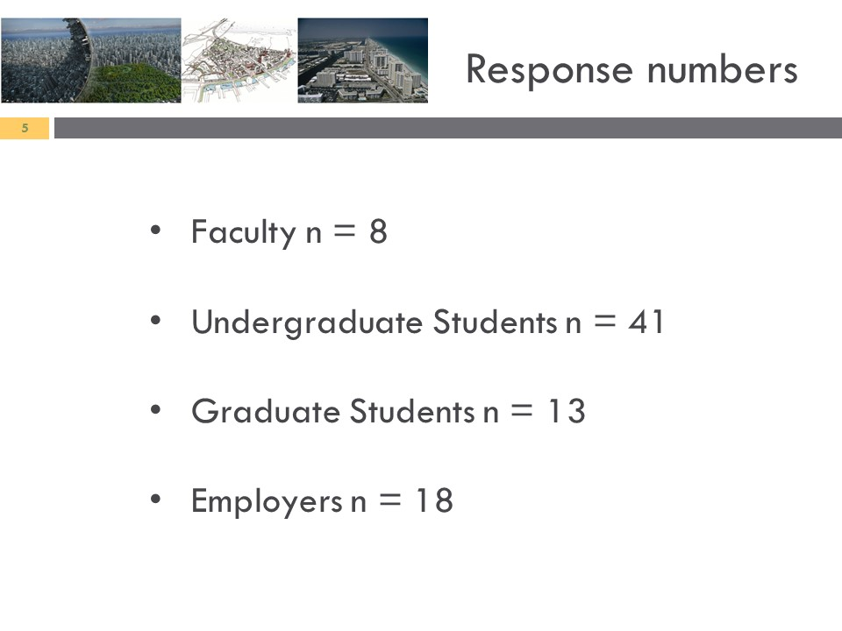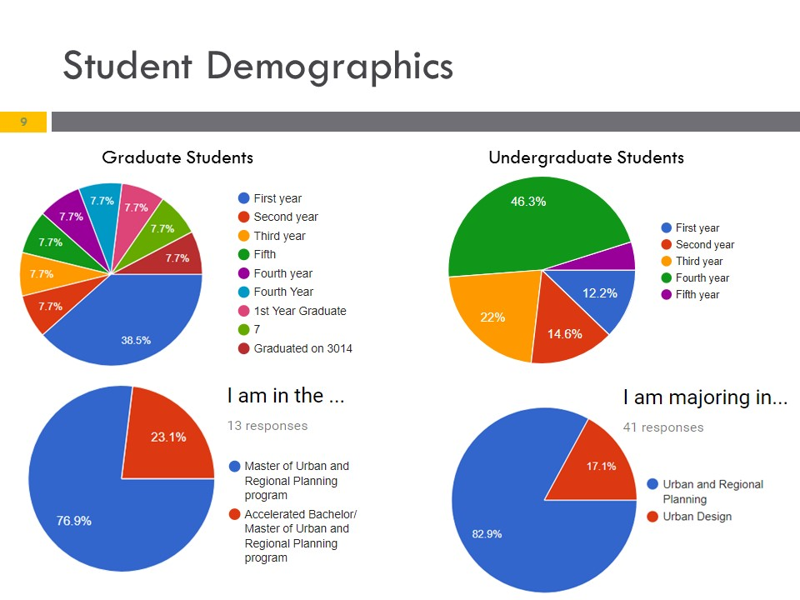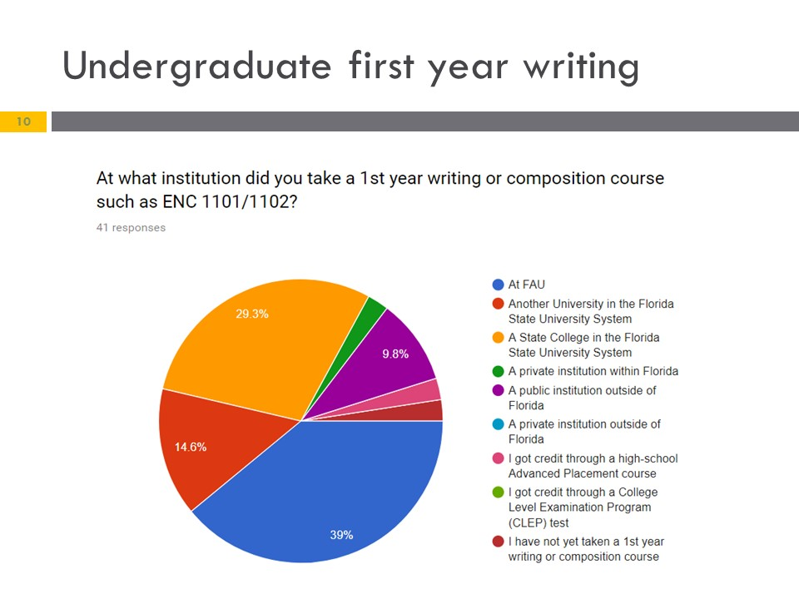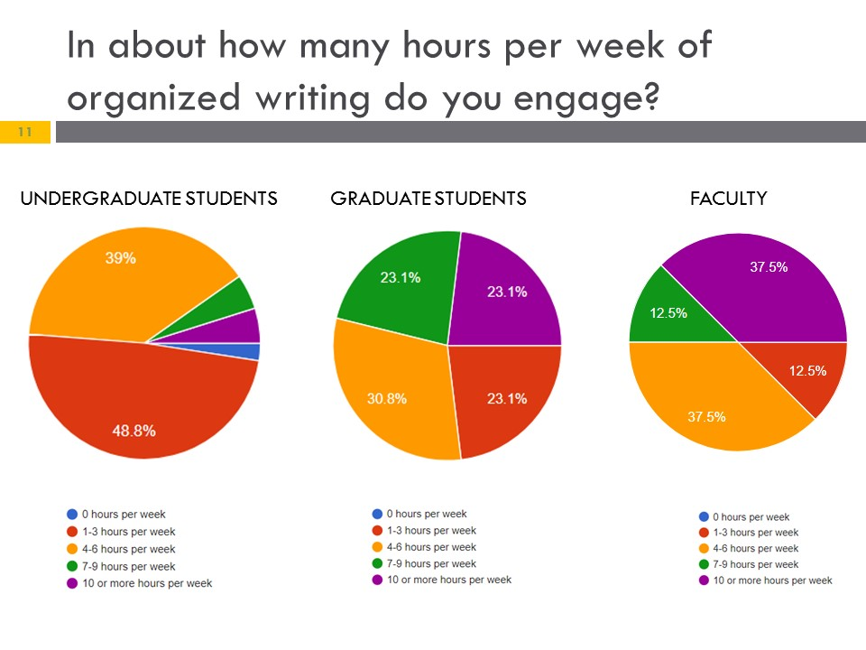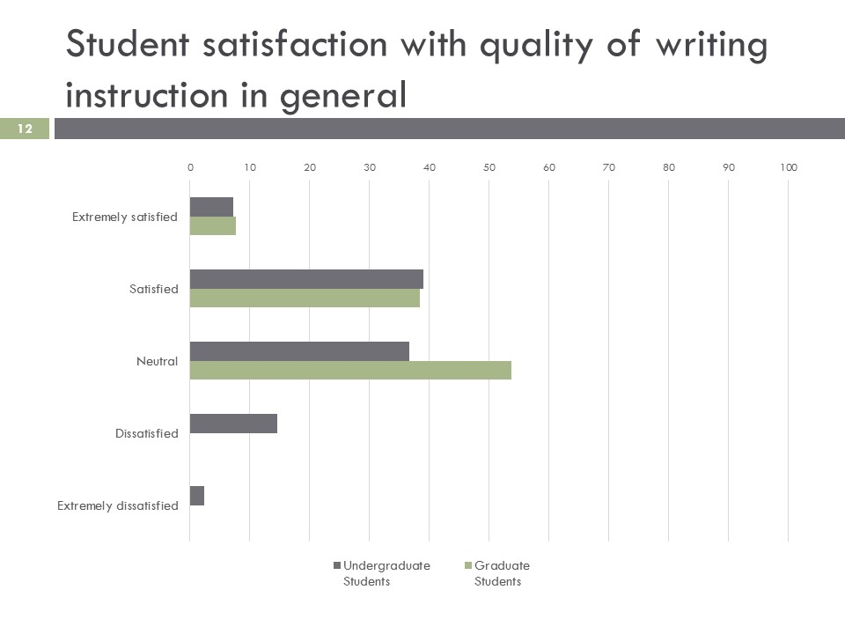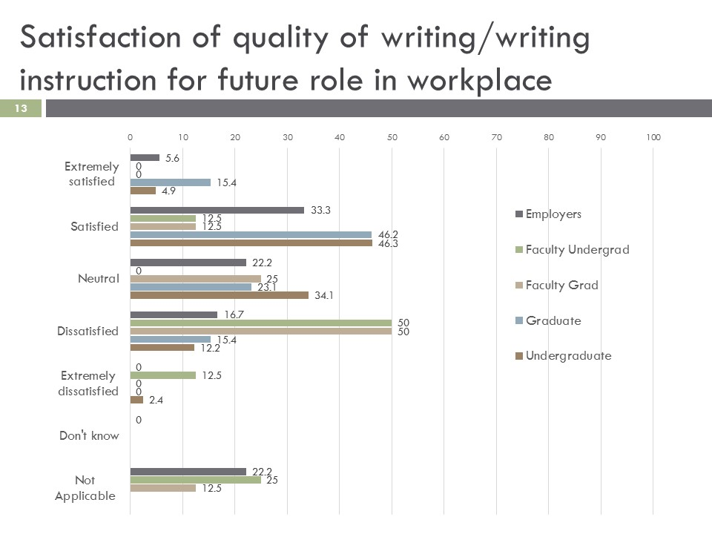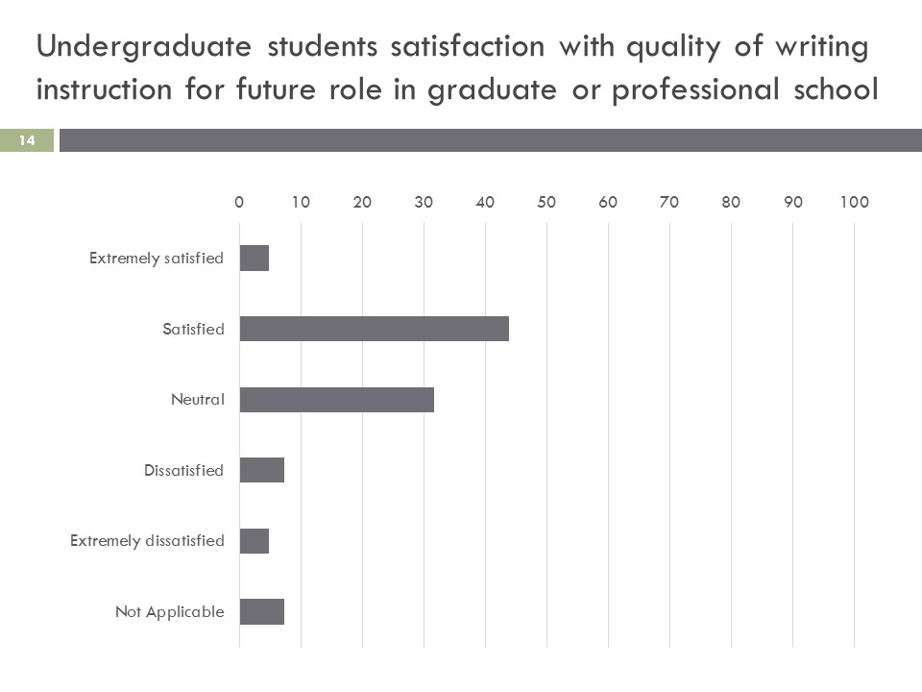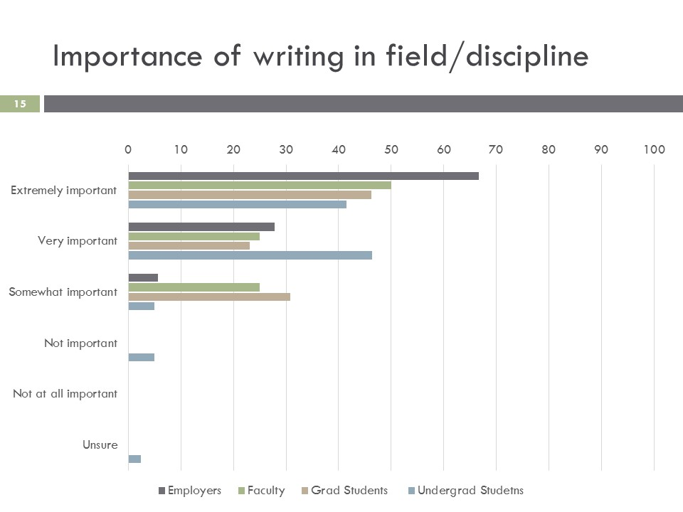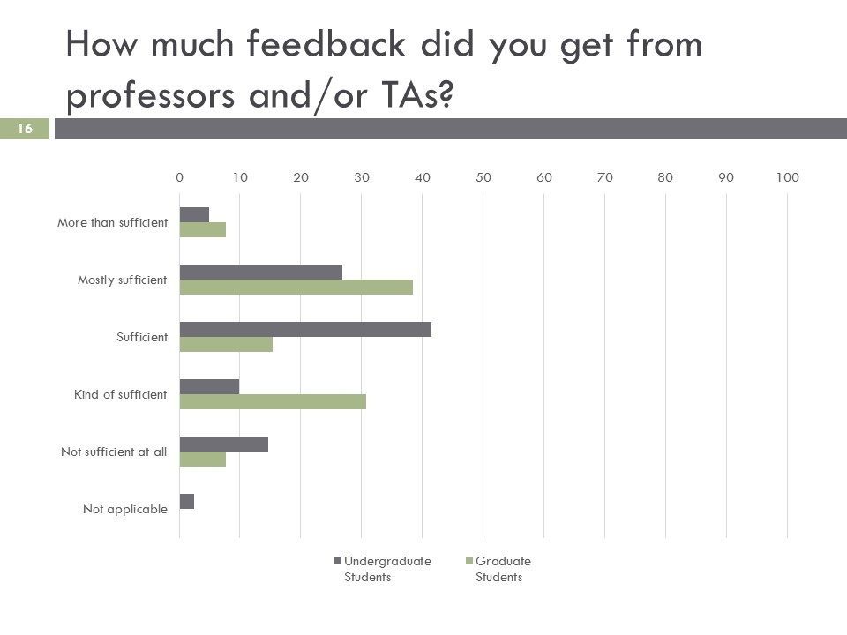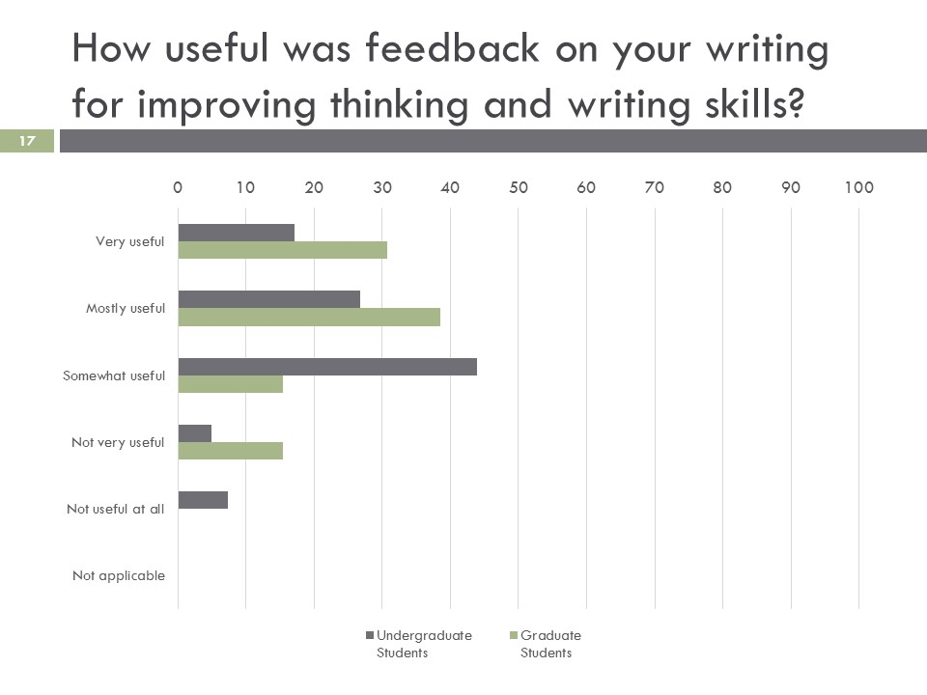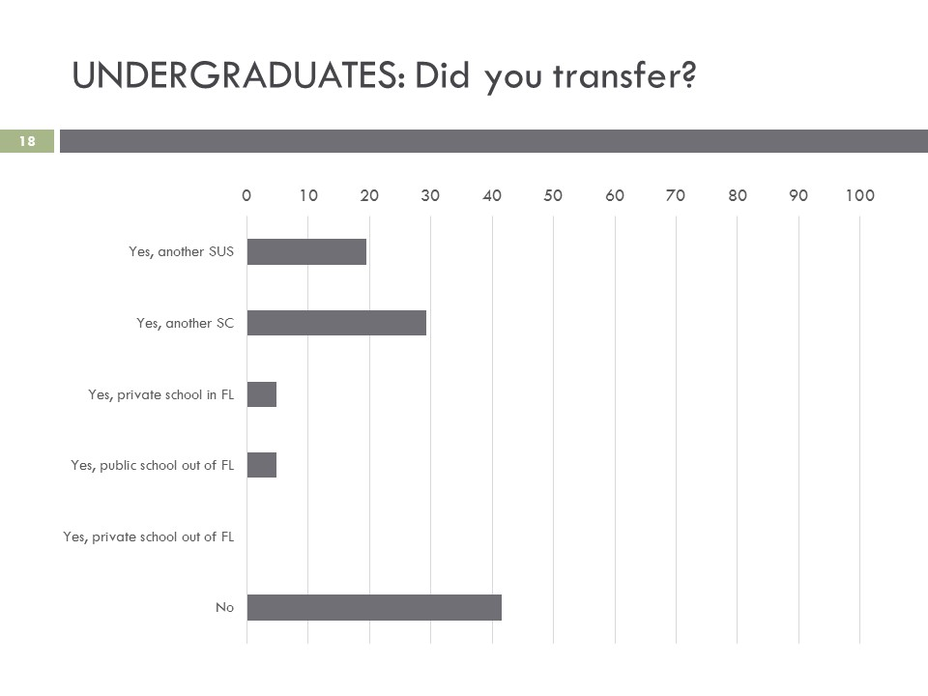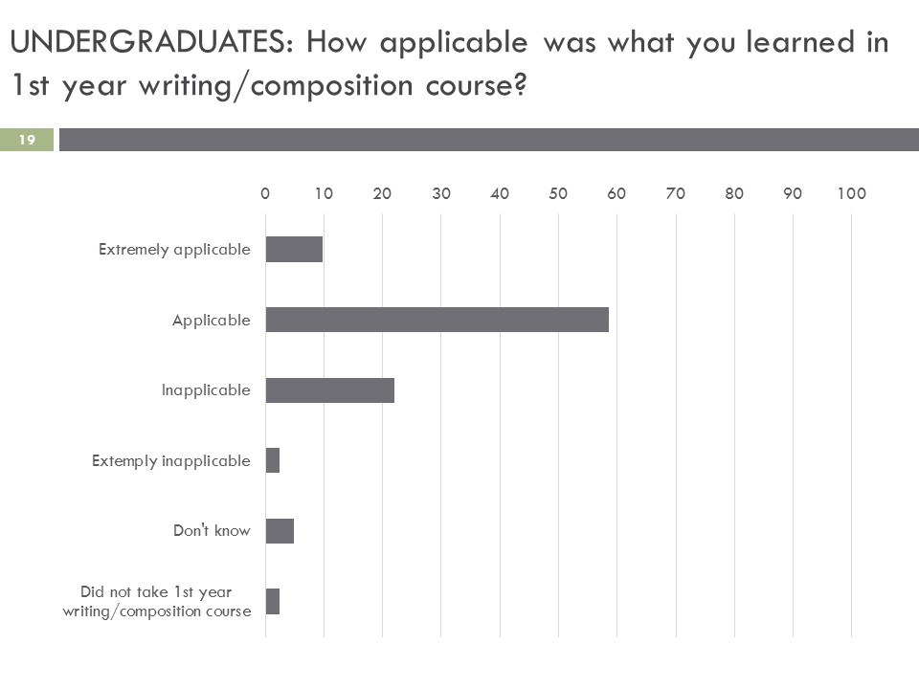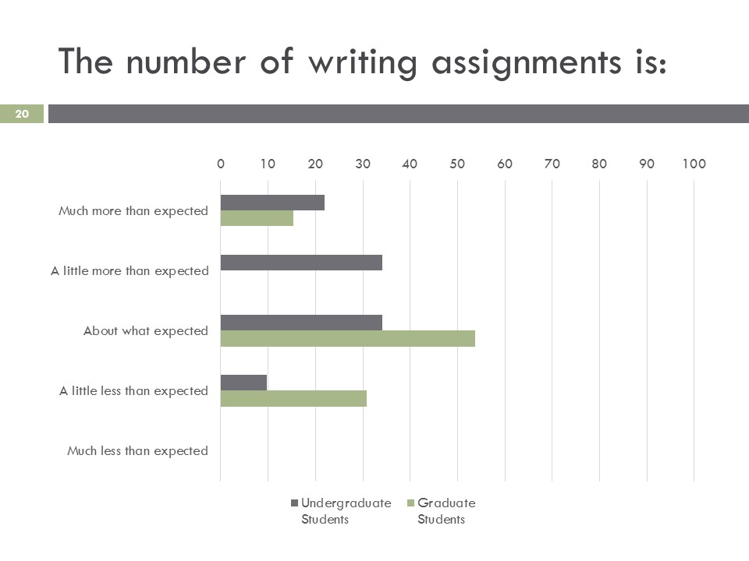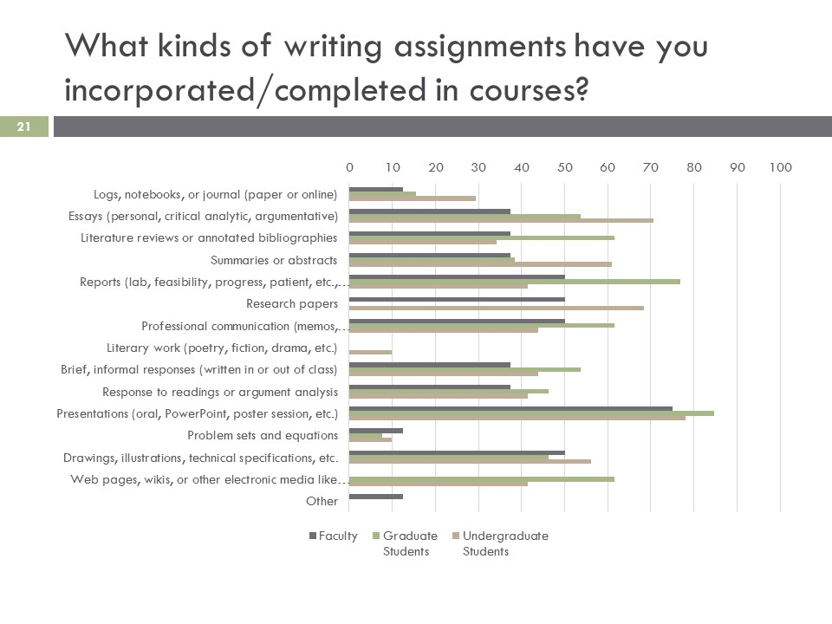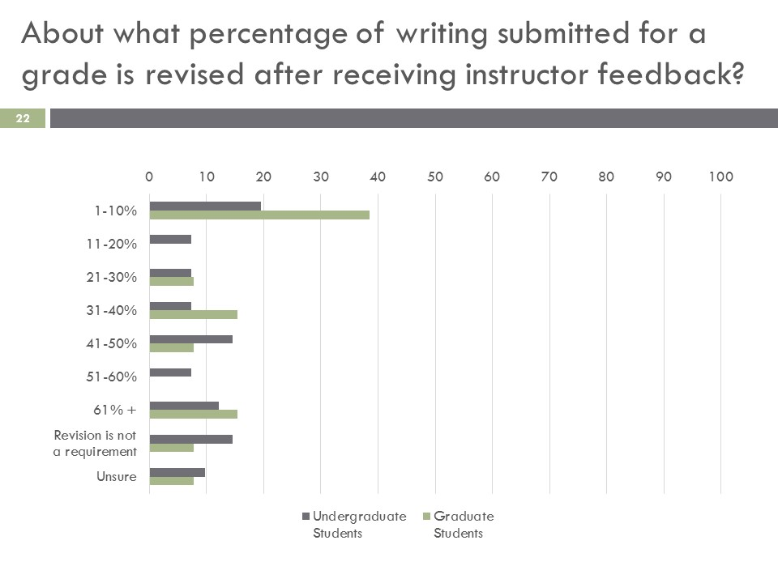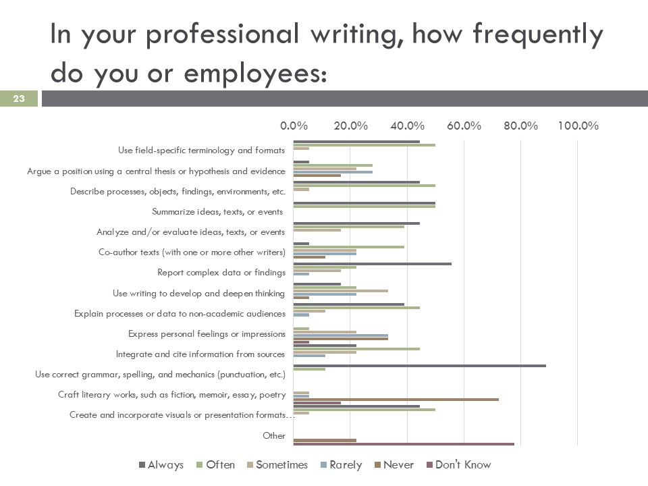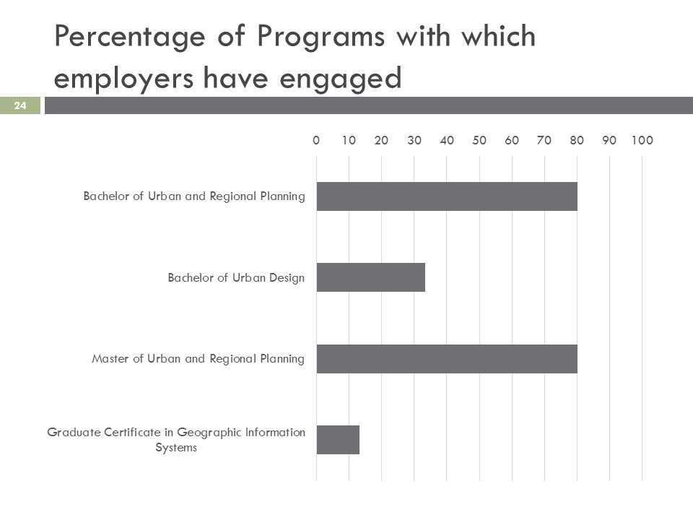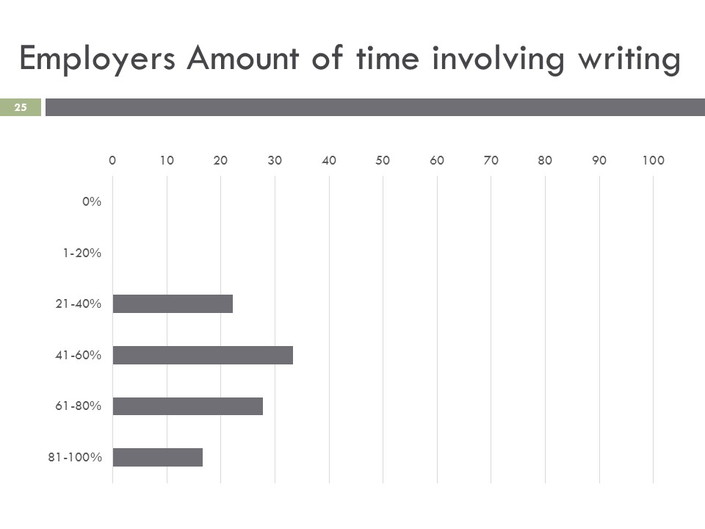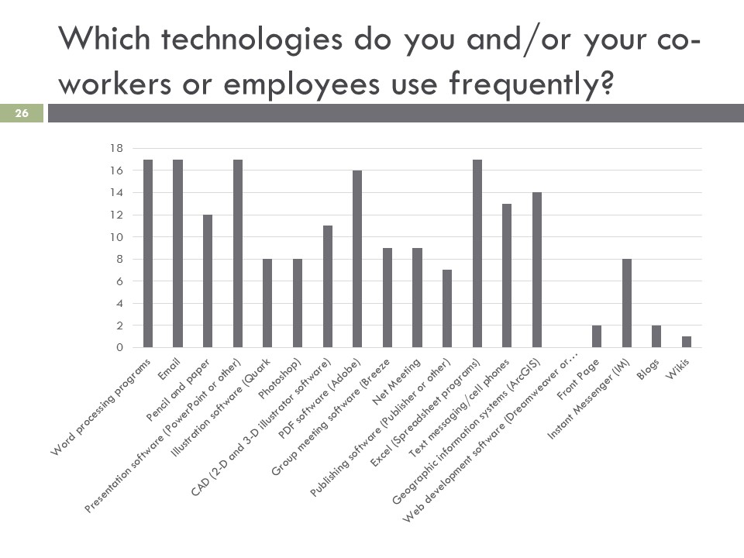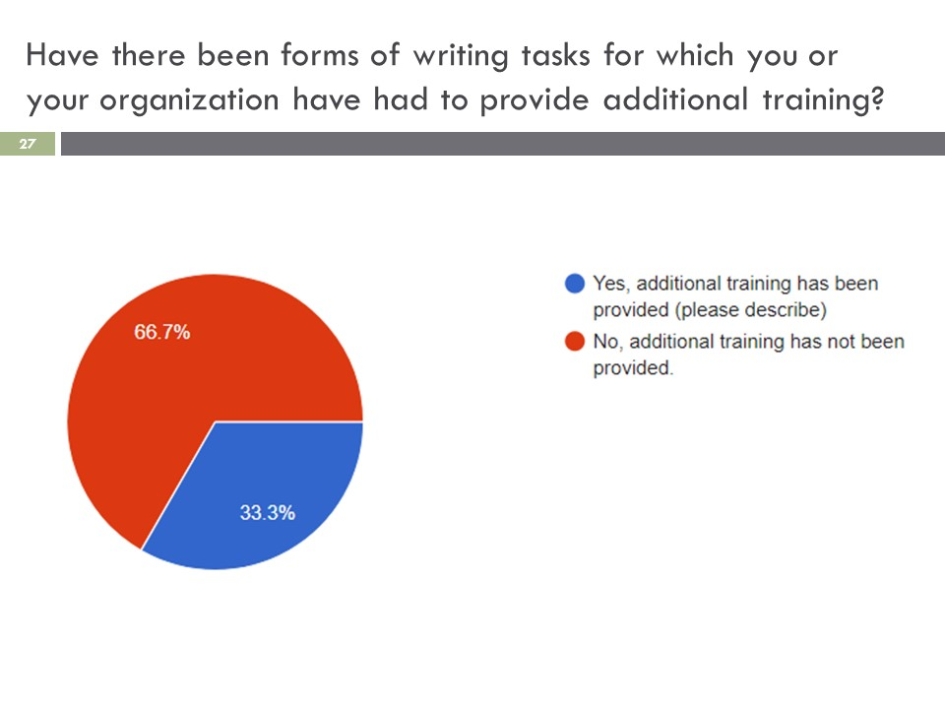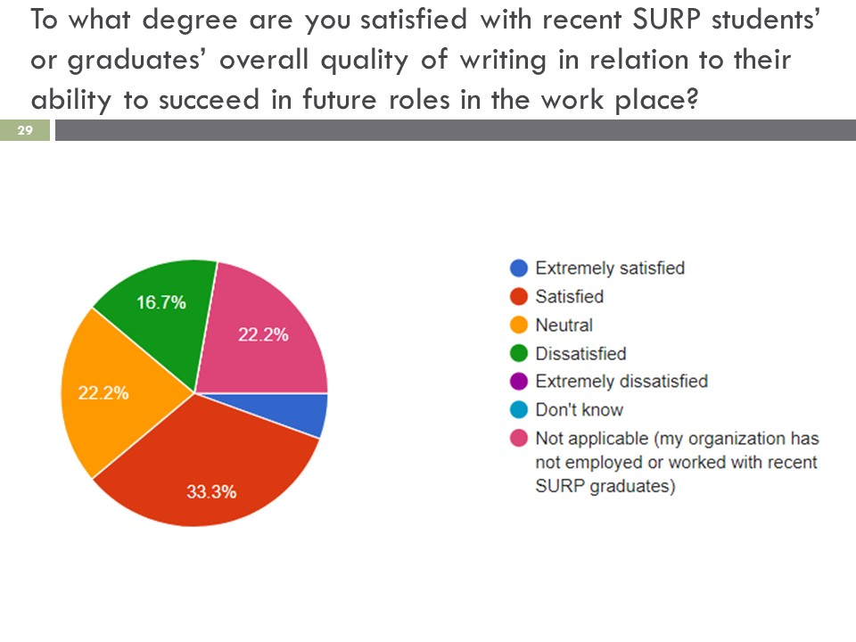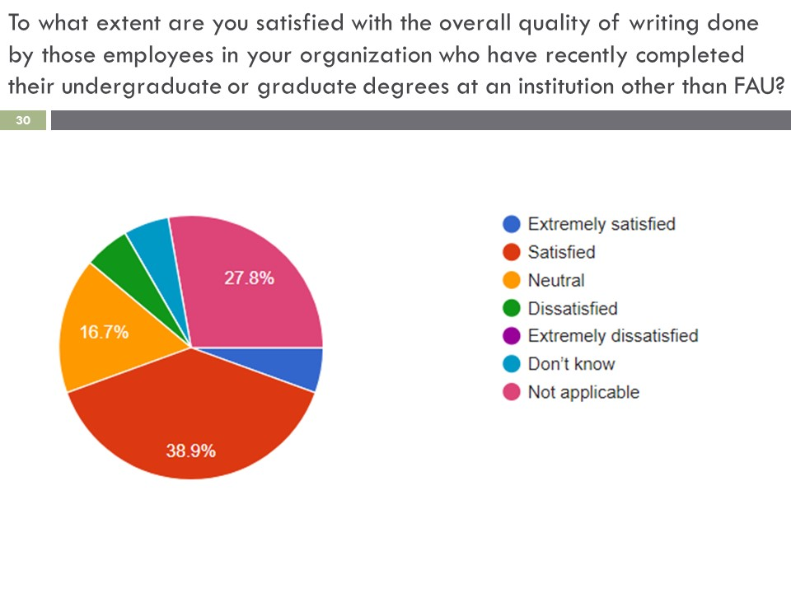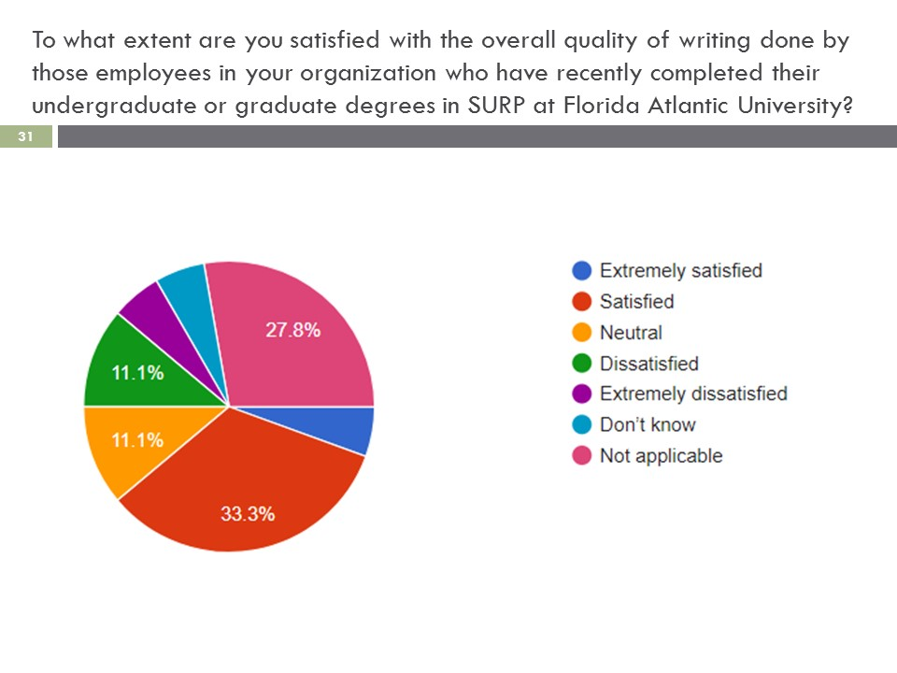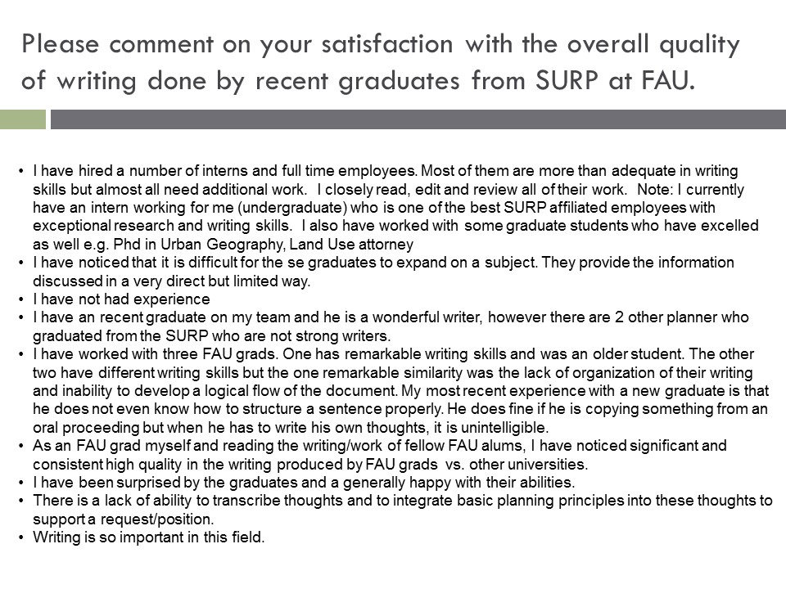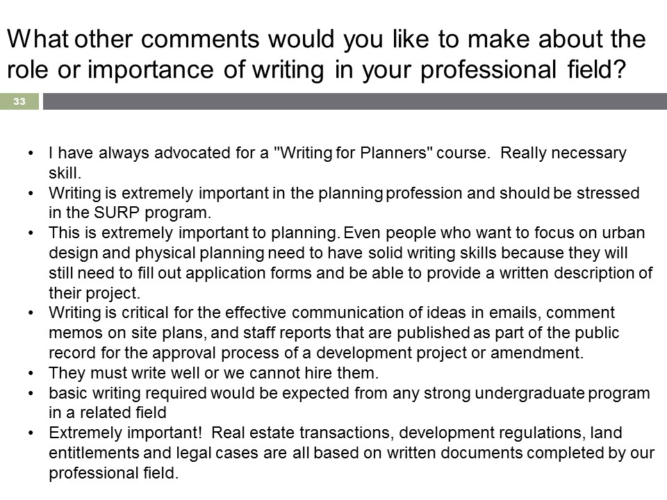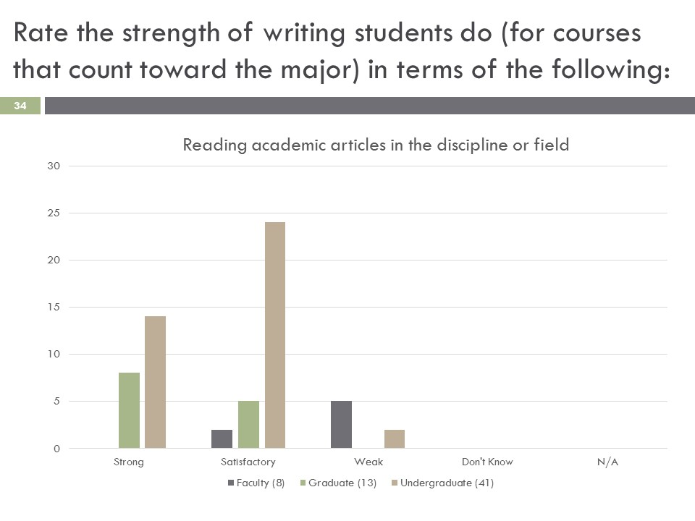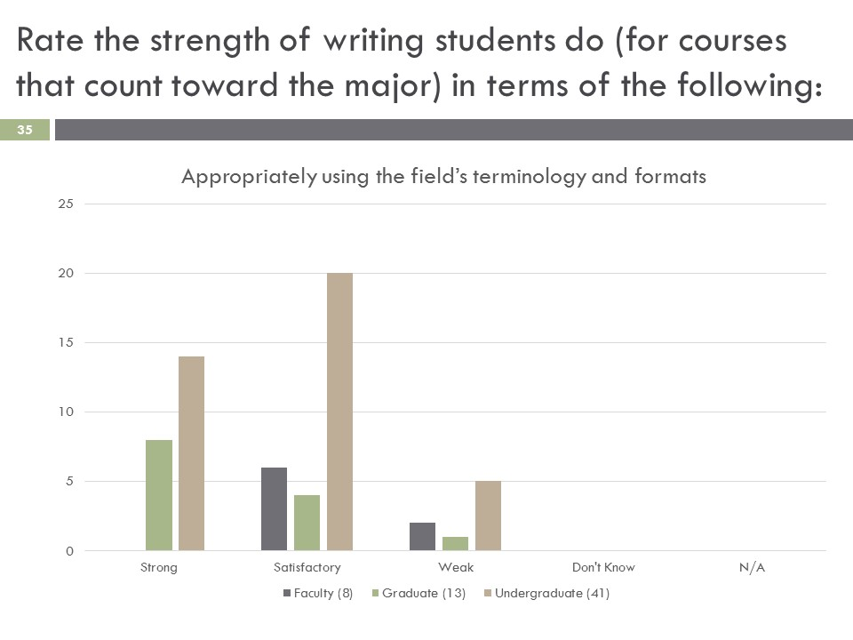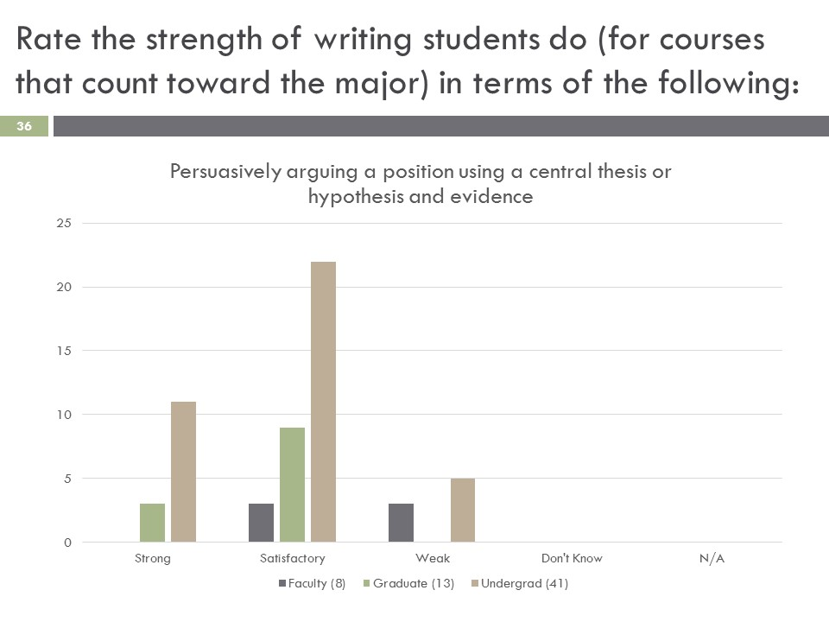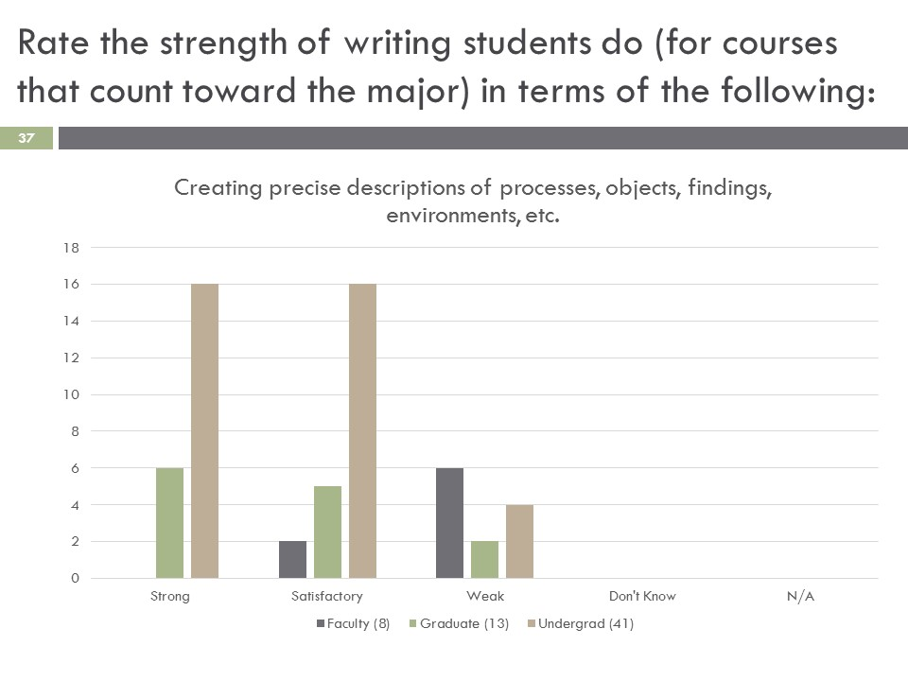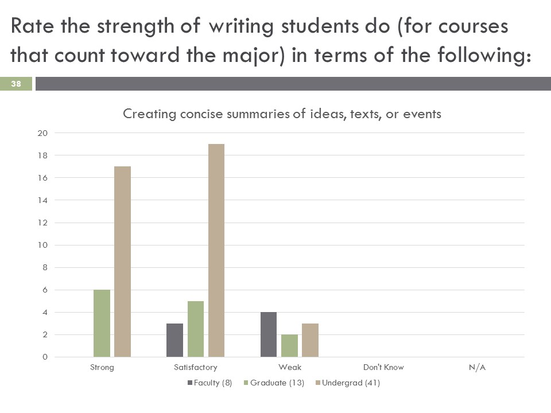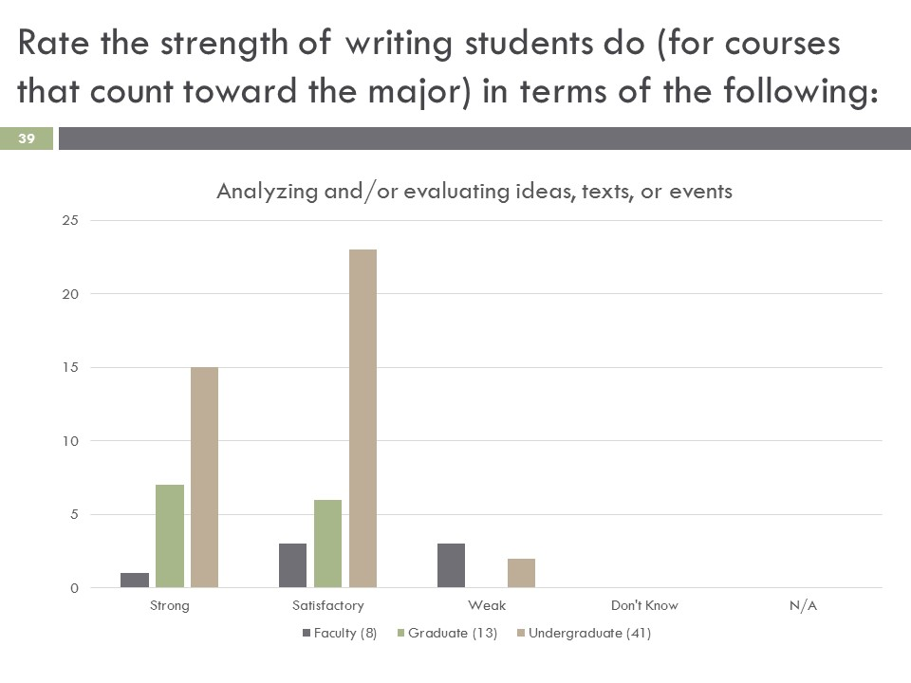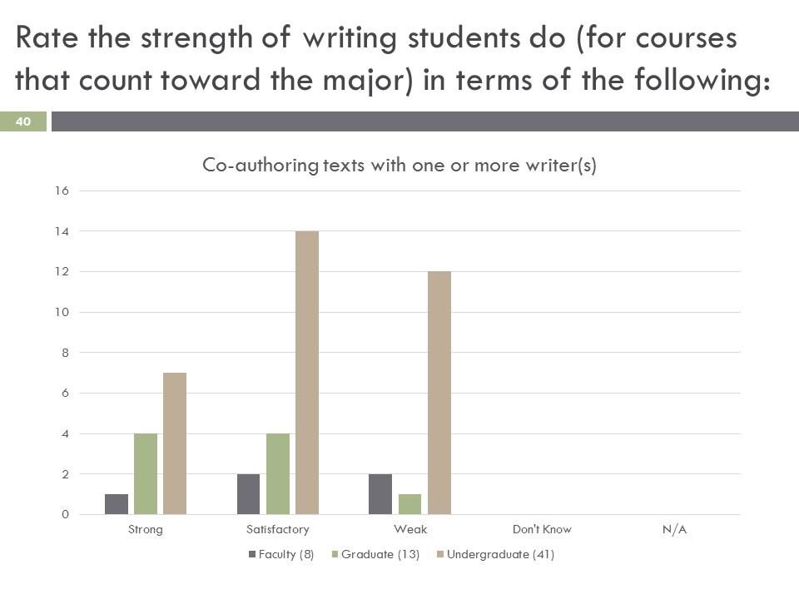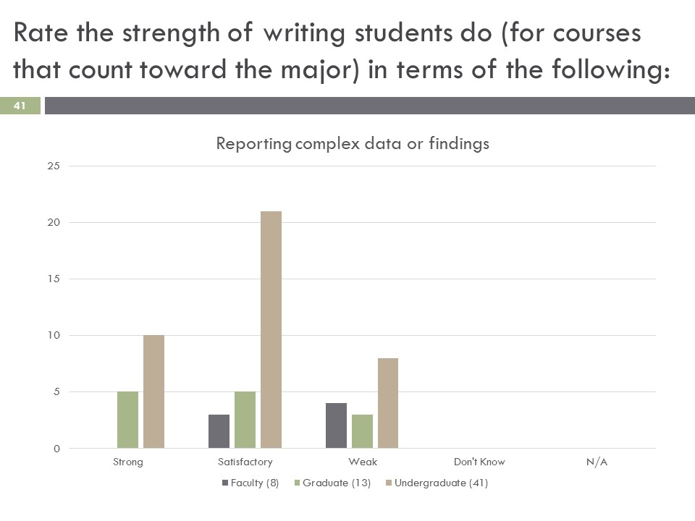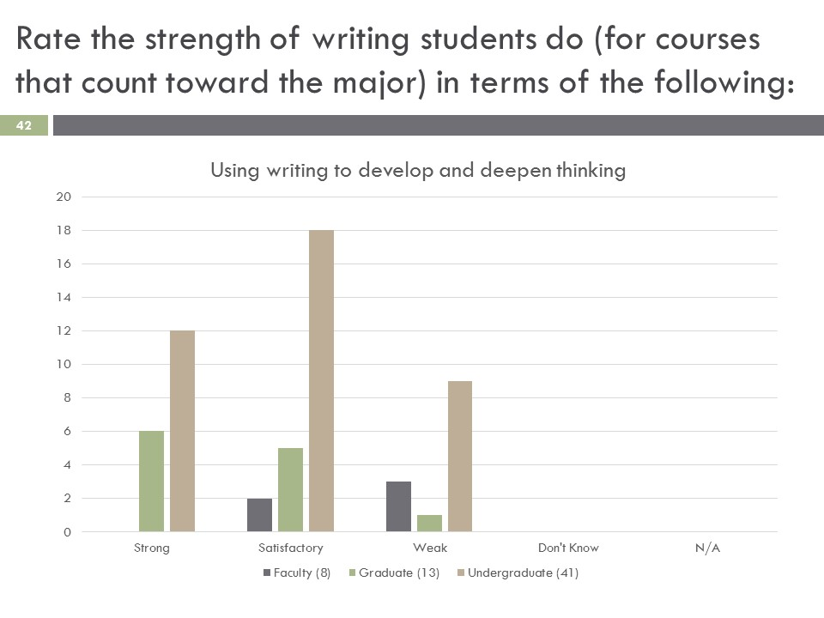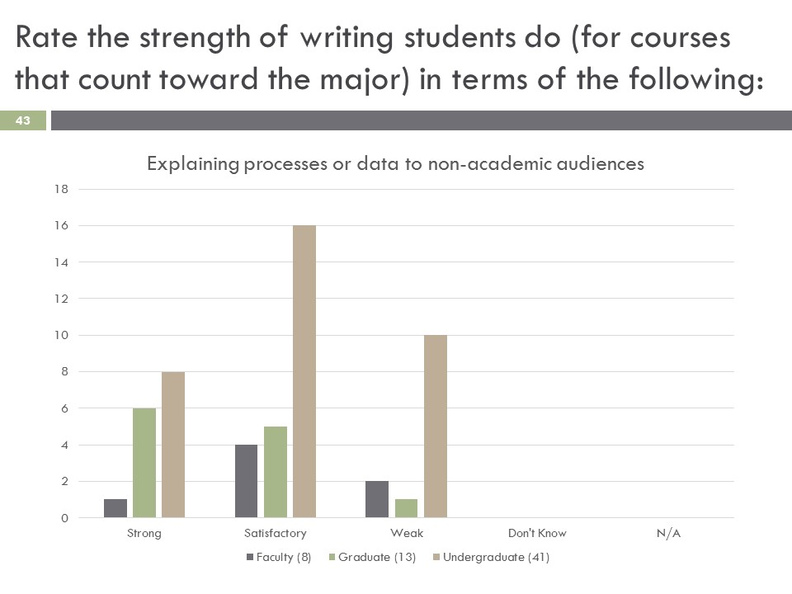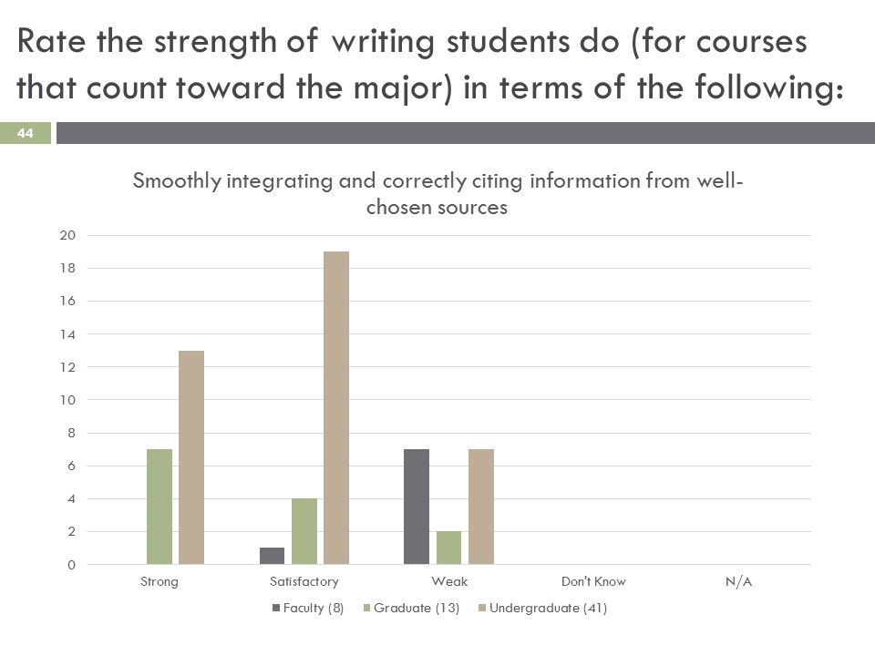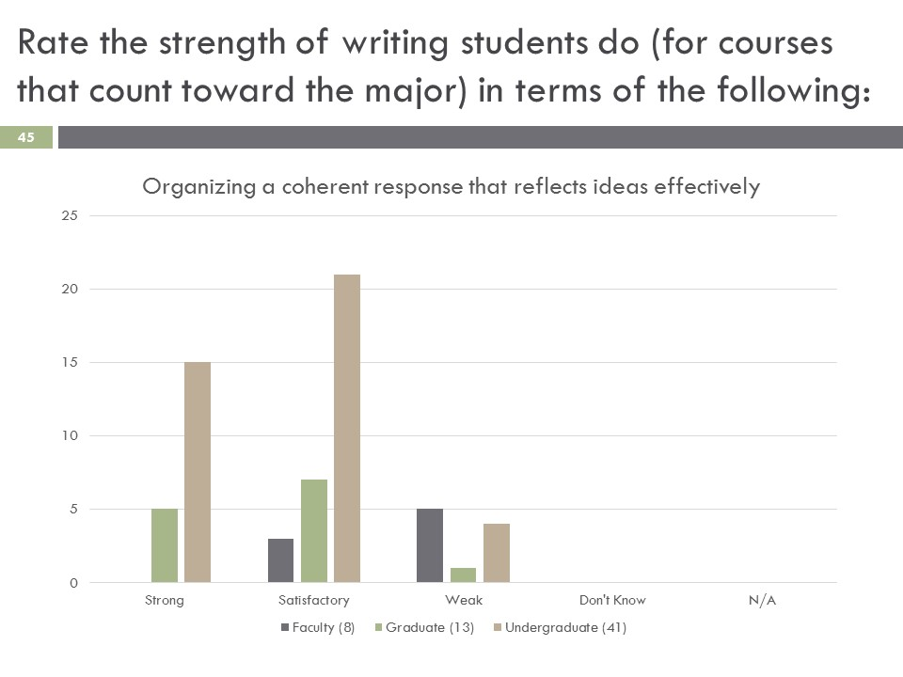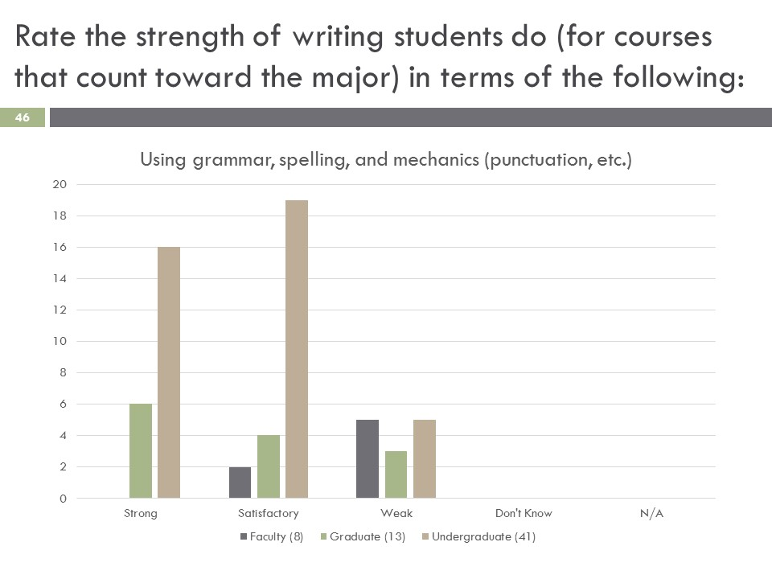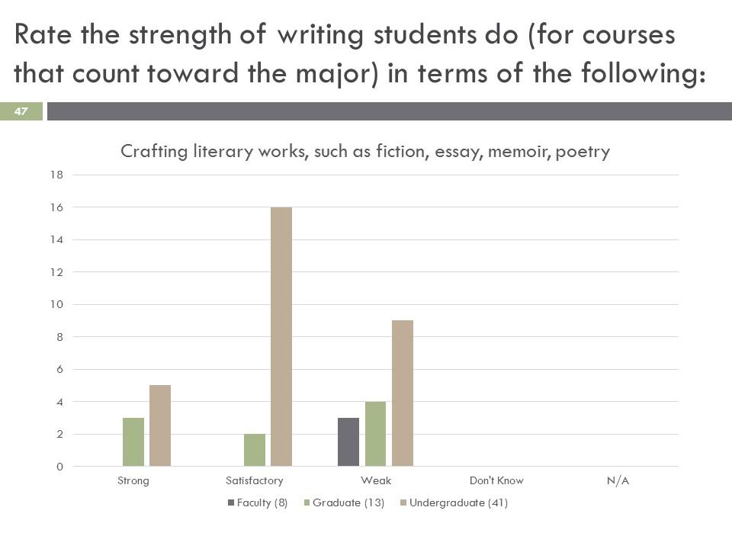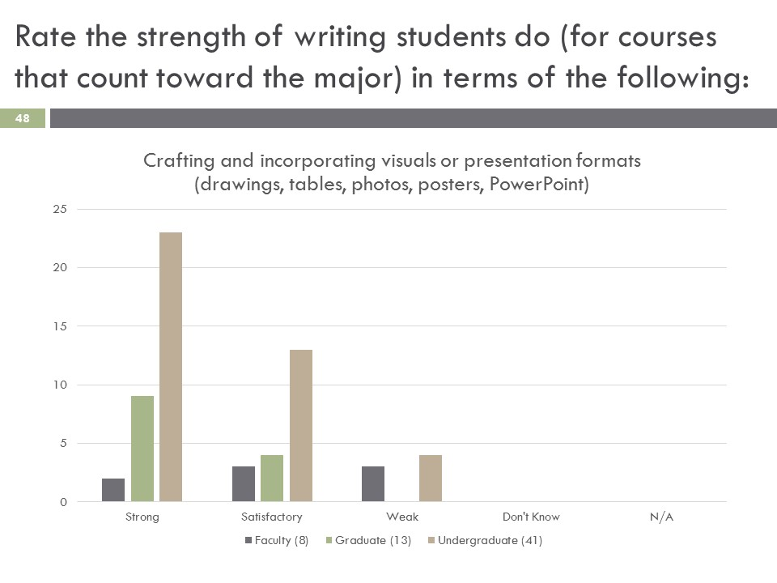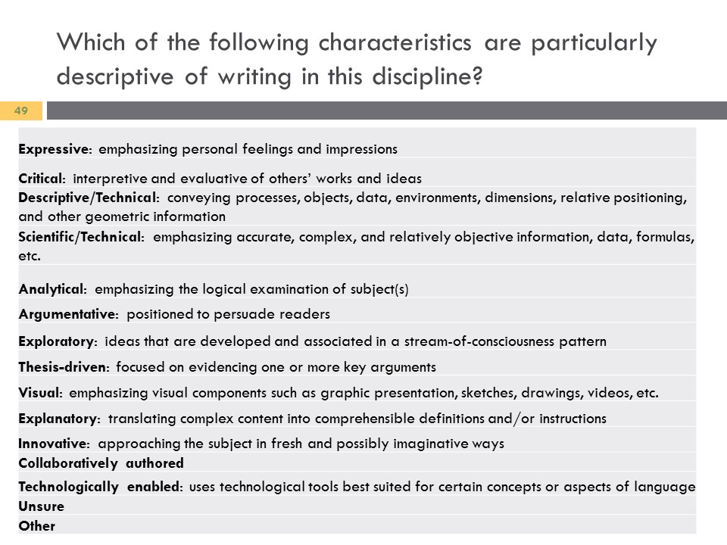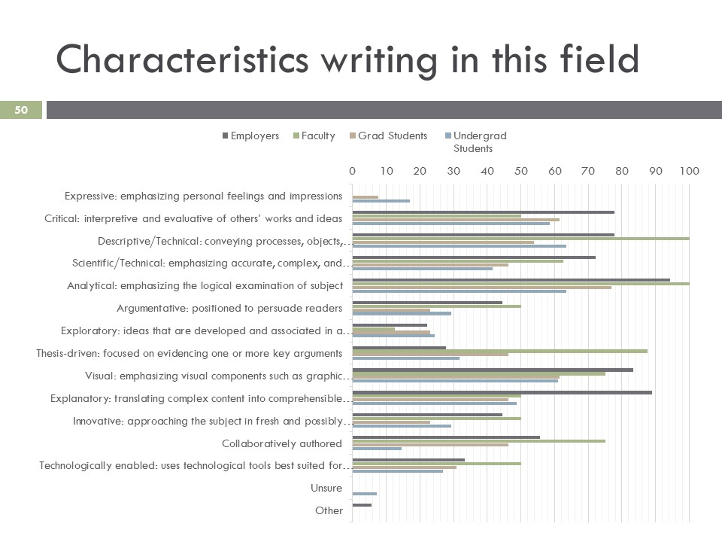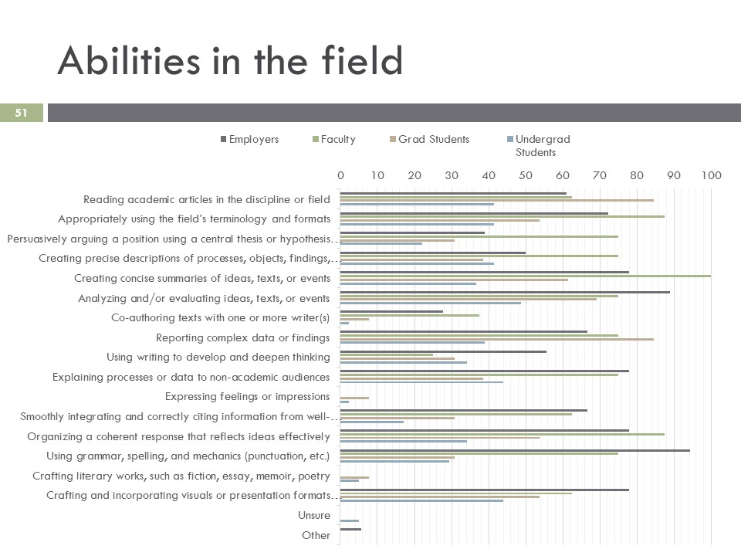

Appendix B: Comprehensive Curriculum Map for each Program

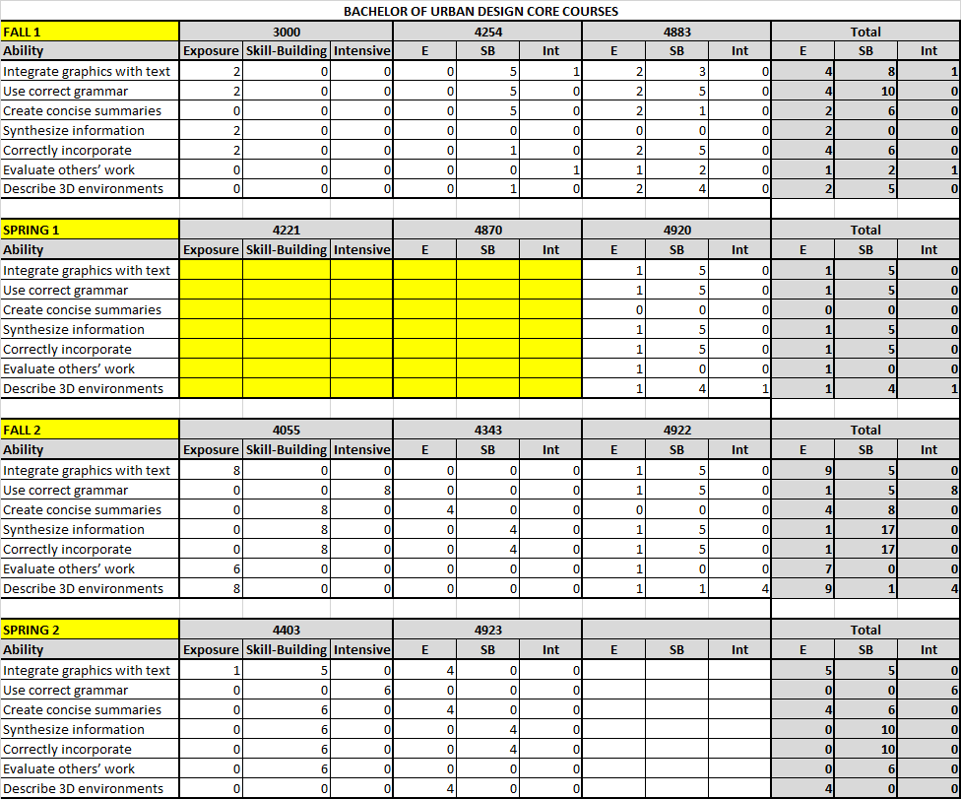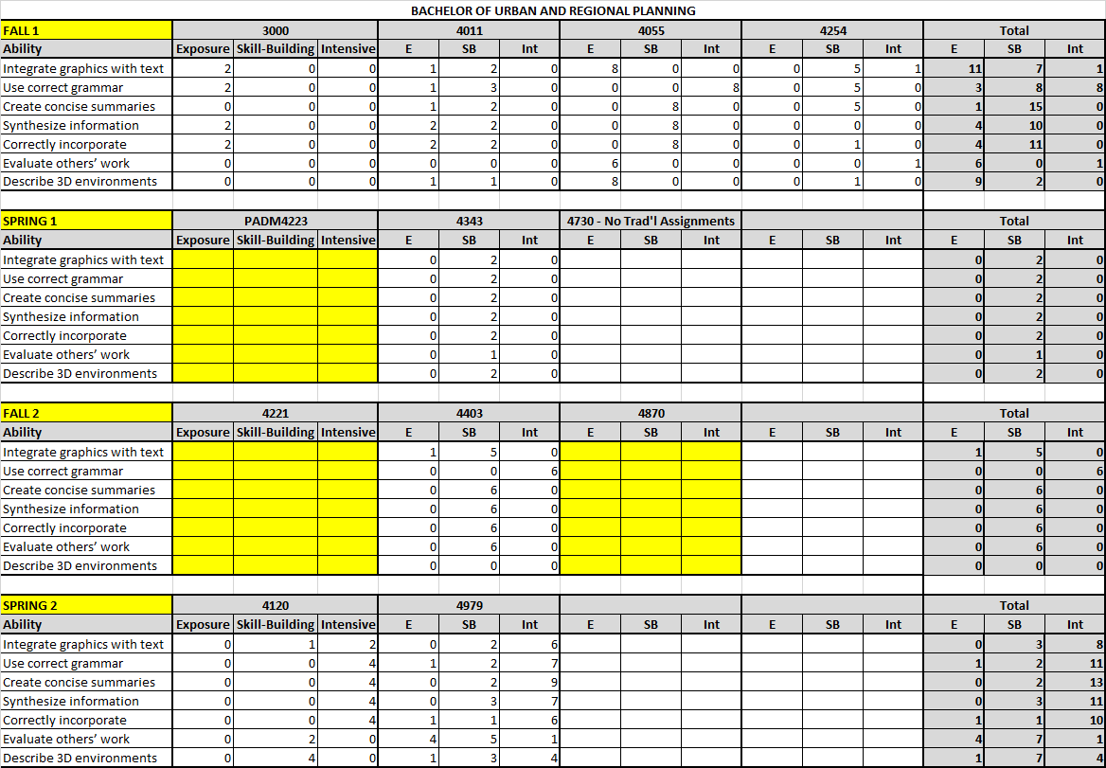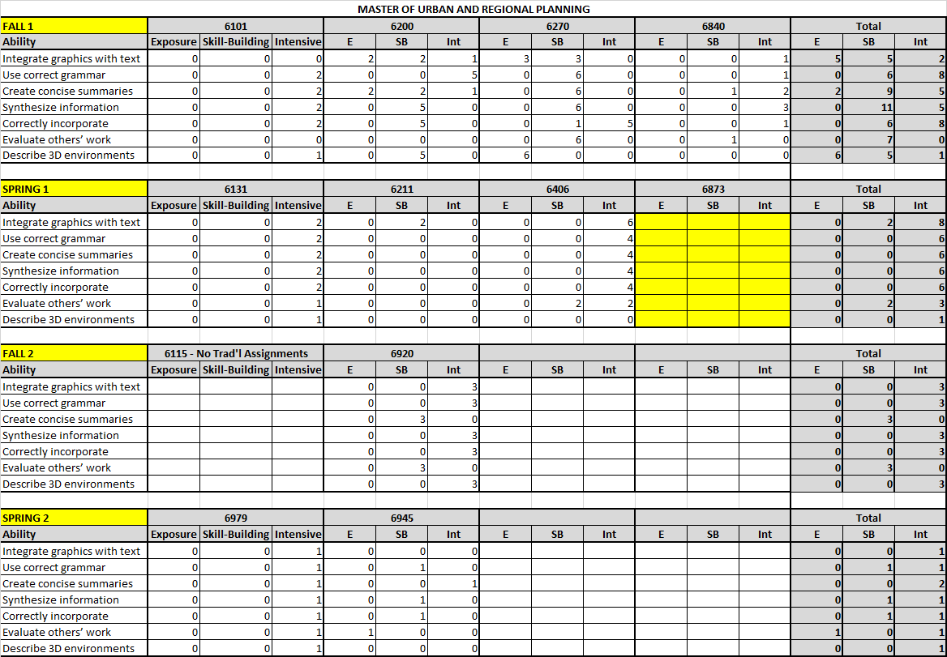

Appendix C: Assessment Rubric

