Department of English
Bldg. 97, Ste. 306, 777 Glades Road
Boca Raton, FL 33431-0991
tel: 561.297.3830 fax: 561.297.3807 www.fau.edu
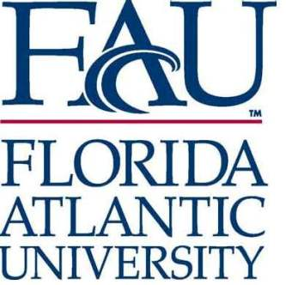

Application for Admission into the English Internship Program
Contact Information
Name: _____________________________________________
Student ID: Z______________________________
Local Address: ______________________________________________
Permanent Address: __________________________________________
Home Telephone: _____________ Work Telephone: ________________
Email Address: _______________ FAU Email Address: _____________

Academic Information
Year in School:___________ Major:___________ Minor:___________

Please list the courses you have completed in English.

Course  Number | Course Title | Professor | Semester | Grade

As a prospective intern, what type of placements interest you most? Please list either general areas of career interest or any specific placement in which you may be interested.

Briefly comment on your career objective. What kinds of skills do you excel at and how do you envision your career plans? With the internship as a learning experience, what types of skills do you plan on developing further?

Have you already held an academic, unpaid internship position? If so, where? What were your responsibilities?

Have you had any non-academic experiences that might qualify you for an internship? Feel free to reference volunteer or paid employment experiences.

Be sure to submit this application with a professional resume free of errors and ready to be received by prospective internship agencies. If you submit a resume that is incorrectly formatted or has multiple errors you will be required to meet with a career advisor from FAU’s Career Development Center to have your resume reviewed.
.

Please sign and return the following waiver form with your application.

FLORIDA ATLANTIC UNIVERSITY
DOROTHY F. SCHMIDT COLLEGE OF ARTS AND LETTERS
DEPARTMENT OF ENGLISH

CONSENT AND RELEASE

I, the undersigned, wish to participate in a Florida Atlantic University internship program arranged by the Florida Atlantic University (FAU) Department of English (the Department).
I state that I am eighteen years of age or older and I am a fully matriculated FAU student. I understand and agree that my participation in the internship program (the Program) is entirely voluntary and in no way constitutes employment with FAU, the State of Florida, or both. I also understand and agree that as an intern I will not be entitled to unemployment compensation based upon any internship employment period.
I state that I am solely responsible for my own participation in the Program and for my own physical well-being. I willingly and knowingly assume for myself, my heirs, family members, executors, administrators and assigns, all risk of physical injury, accident, or death, and any property loss of any kind which may occur before, during, or after my participation in any aspect of the Program. Being aware of risks inherent in the Program activities, I nonetheless voluntarily choose to attend and participate in the Program activities, and I assume all risks arising out of them, including travel to and from the various Program locations.

In exchange for permission to participate in the Program, I release, acquit, forever discharge and waive any claims which I may have against the State of Florida, the Florida Board of Regents, Florida Atlantic University, the Department and their respective employees, officers, and agents of any and all of the foregoing, and I hold them free and harmless of and from all actions, causes of action, claims, damages, and costs arising from and accruing to me on account of any and all accident or injury to me, or death, or loss of any property of any kind directly or indirectly sustained by me as a consequence of my travel to and from, and my participation in any aspect or activity of the Program.

I have read and understand the provisions of the foregoing Consent and Release document and do freely accept its terms.
________________________________________________________________________
Signature of Participant

Date
________________________________________________________________________
Print Name of Participant

