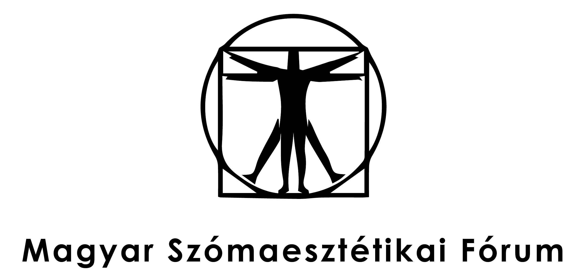

**The Promise of Pragmatist Aesthetics:**

**Looking Forward after 30 Years.**

Call for Abstracts

Shusterman’s significant book, *Pragmatist Aesthetics* was published in 1992. Due to the author’s multicultural background, diverse philosophical research (analytic aesthetics, pragmatism, Adorno, Bourdieu, etc.) and his attractive topics of inquiry (rap, popular art, body culture), his work revitalized aesthetic discussions. At the turn of the new century, with the book’s second edition, Shusterman launched his new project of somaesthetics, which is essentially an extension of his approach to pragmatist aesthetics. As he wrote in that second edition.

"There is already an abundance of discourse on the body in contemporary theory. But such body talk tends to lack two important features. *First, it needs a structuring overview or architectonic* to integrate its very different, seemingly incommensurable, discourses into a more productively systematic field. It would be useful to have a comprehensive framework that could connect the discourse of biopolitics with the therapies of Bioenergetics and might even link analytic philosophy's ontological doctrines of psychosomatic supervenience to bodybuilding's principles of supersets. *The second thing lacking in most current philosophical body talk is a clear, pragmatic orientation* – something that the individual can directly translate into a discipline of improved somatic practice. Both of these deficiencies can be remedied by the proposed field of somaesthetics, a discipline of theory and practice." (PA 271 – Emphasis added by A. Kremer.)

During the last three decades, *Pragmatist Aesthetics* has been translated into fourteen languages, and the pragmatist approach to aesthetics has become an important direction in the philosophy of art and the aesthetic field. Similarly, somaesthetics has developed into an interdisciplinary field with researchers working in the arts, politics, education, historical and social sciences as well as health sciences and even technology.

In May 2012 the Sorbonne’s philosophy and art departments arranged an international conference and an art show to mark the progress of pragmatist aesthetics since the simultaneous publication of Shusterman’s *Pragmatist Aesthetics* and its French version entitled *L’Art à l’état vif*. The conference was called "Pragmatist Aesthetics: 20 years later / L’art à l’état vif: 20 ans après” and the art show’s title was *Aesthetic Transaction:* *Pragmatist Philosophy through Art and Life*.

Ten years later we wish to explore the melioristic approach and multiple forms and impacts of pragmatist aesthetics and somaesthetics, not with a mere retrospective regard but with an interest on new thinking for the future. That is why the MOME (Moholy Nagy University of Art and Design) and the Hungarian Forum for Somaesthetics are organizing a conference in Budapest between May 25-28th, 2022. The title of the conference is "The Promise of Pragmatist Aesthetics: Looking Forward after 30 Years.” Possible topics include, but are not limited to, investigations into the following phenomena and trends:

- pragmatist aesthetics in the 21st century (theories, art criticism, institutionalization)

- implications of pragmatist aesthetics on artistic and other creative practices (design, fashion, gastronomy, urbanism, etc)

- pragmatism, somaesthetics, and artistic research

- pragmatist aesthetics and the place of arts in the social life

(everyday aesthetics, arts and politics, collaborative artistic practices)

- pragmatist aesthetics and somaesthetics

- pragmatist aesthetics and performativity

- pragmatist aesthetics and the digital future of arts

- pragmatist aesthetics, somaesthetics, and politics

- pragmatist aesthetics, somaesthetics, and education

- somaesthetics and technological design

- pragmatist aesthetics and social sciences

**Keynote speakers:**

* **Prof. Richard Shusterman**
* **Prof. Barbara Formis**
* **Prof. Giovanni Matteucci**
* **Prof. Tanehisa Otabe**

**The organizing committee:**

**Alexander Kremer** (SZTE, Hungarian Forum for Somaesthetics), habil. associate professor  
**Bálint Veres** (MOME), habil. associate professor  
**Attila Horányi** (MOME), associate professor **Botond Csuka** (University of Physical Education, Budapest) assistant professor

**Abstract’s deadline: December 15, 2021**

**Abstracts should be sent to the following email address:** [**pragmatistaesthetics@mome.hu**](mailto:pragmatistaesthetics@mome.hu)

**Notifications of acceptance: January 15, 2022**